Review 2 for Spring 2012 Final Exam Algebra 2 Name __________________________

Multiple Choice
1 The function is a growth or decay? Choose the graph of the function.

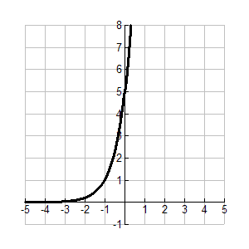
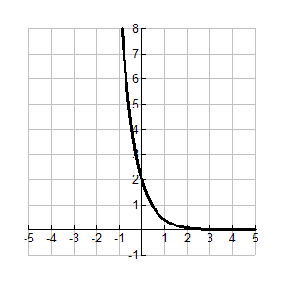
a. This is an exponential growth function. c. This is an exponential decay function.

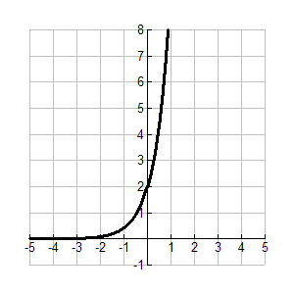
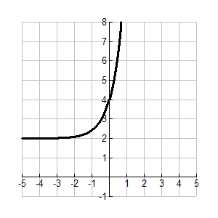
b. This is an exponential growth function. d. This is an exponential growth function.

2. Write the exponential equation in logarithmic form.

a. b. c. d.

3. Write the logarithmic equation in exponential form.

a. b. c. d.

4. A bacteria population starts at 3,000 and decreases at about 12% per day. Write a function representing the
number of bacteria present each day. After how many days will there be fewer than 500 bacteria?

a. b. c. d.

5. Choose the graph of the function and its inverse. State the equation of the inverse of .
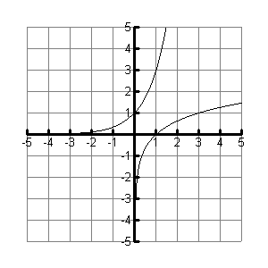
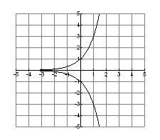
a. b.

c. d.
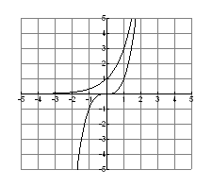
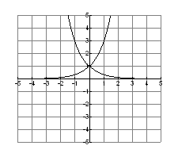

6. The amount of money in a bank account can be expressed by the exponential equation
where A is the amount in dollars and t is the time in years. About how many years will it take for the
amount in the account to be more than $900?

a. 3 years b. 19 years c. 35 years d. 121 years

7. Solve

a. b. c. d.

8. Solve . Check your answer.

a. b. c. d. no solution

9. Simplify the expression . Assume that all variables are positive.

a. b. c. d.

10. Write the expression in radical form, and simplify. Round to the nearest whole number if necessary.

a. b. c. d.

11. Write the expression by using rational exponents.

a. b. c. d.

12. Solve .

a. b. or c. d. no solution

13. Solve

a. x = 27 b. c. x = d. no solution

14. Given and , find .

a. b. c. d.

15. Given and , find .

a. c.

b. d.

16. Given and , find .

a. 25 b. 36 c. 28 d. 19

17. Given and . Which of the following is a true statement?

a. b. c. 9 is not in the d. is not in the
domain of domain of

18. Solve the equation or formula for the indicated variable. . Solve for t.

a. b. c. d.

19. Which of the following is not equal to ?
a. b. c. d.

20. Which value is equivalent to ?

a. b. c. d.

21. Which exponential function models a population of 100 chickens decreasing at an annual rate of 5%?

a. b. c. d.

22. What expression is equal to ? Show how you could find the answer without using a calculator.

a. b. c. d.

23. Simplify

a. b. c. d.
24. If , what is ?

a. b. 9 c. d. 1

x | -3 | -2 | -1 | 0
y | 5 | 4 | 0 | 4
25. Give the domain and range of the function:

a. Domain: b. Domain: c. Domain: d. Domain:
Range: Range: Range: Range:

26. Evaluate .

a. 2 b. 4 c. 8 d. 27

27. Which statement is not true about a function f and its inverse ?

a. A rule for can be found by switching x and y. c. The range of is always the same as the
domain of f.

b. A reflection about the line maps the graph d. A reflection about the maps the graph
of f onto the graph of . of f onto the graph of .

28. Write the expression below using rational exponents.

a. b. c. d.

29. Which of the following is equal to ?

a. b. c. d.

30. Solve
a. b. c. d.

31. Which statement is not correct?

a. c.

b. d.

32. Which expression is equal to ?

a. b. c. d.

Short Answer / Open Response

33. Determine whether each data set represents a direct variation, an inverse variation, or neither. Show your work to verify.
a. b.
x | 12 | 14 | 16 | 20
y | 2 | 7/3 | 8/3 | 10/3
x | 30 | 15 | 20 | 12
y | 2 | 4 | 3 | 5

34. Solve the equation .

35. The money you earn varies directly with the number of lawns you mow. You earn $36 for mowing
three lawns.

- Write an equation for the relationship between money earned and lawns mowed.

- How much money would you earn for mowing seven lawns?

36. Find the solution of .

