Extra Review Problems Semester 2:
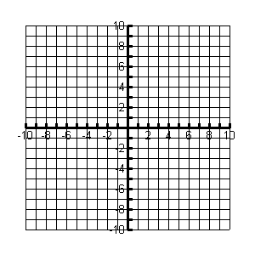
1. Write the logarithm below in exponential form and then graph.

Exponential equation _______________

2. Graph the inverse function

3. Graph the relation given by the points in the table below and connect the points. Then graph the inverse.
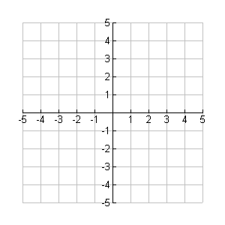
X | - 2 | 0 | 2 | 5
Y | - 4 | -3 | 1 | 3

A) Domain of the given function: _________________

B) Range of the given function: __________________

C) Domain of the inverse: _______________________

D) Range of the inverse: ________________________

4. Write in the order from least to greatest:

5. Complete the following (without a calculator):

_____ _____ _____ _____

- Solve: ______

Simplify. Assume that all expressions are defined.

7.

8.

