In this lab, we will continue our exploration of statistics. You will perform this investigation as part of a group and your group will submit one product. Your group needs to collect your data in one class period, and do the analysis afterwards.

Bananas are special foods that come with a protective scab. The goal of this investigation is to examine the cost of the food that you consume in a banana by looking at the mass and volume of a banana.

1. Your group will need to collect 7 bananas from the banana’s home base. Select bananas of different lengths from short to long and sizes from small to large.

2. For each banana you will need to collect the following information. To keep the data organized you need to identify each banana. Volume should be collected by displacement in water, and the scabbed volume should be collected first.

Name | Mass with Scab  (gram) | Volume with Scab  (cc) | Scabless Mass  (gram) | Scabless Volume (cc)
3. To do the analysis of the data you will need the data from part two for all the bananas in the room. Check with the other groups and swap data. You should have data for 7 bananas from each group and your own data for the next steps.

4. Place all of the data from the class in your Nspire. Create a graph of the Scabbed Mass vs. Scabbed Volume and get the equation that fits this curve. The slope of this line will be the density of a banana with its scab.
X = Scabbed Volume, Y = Scabbed Mass

5. Repeat part 4 with the data for the de-scabbed banana.
X = Scabless Volume, Y = Scabless Mass

6. Compare the two graphs.

7. The density for each individual banana can be calculated by dividing each bananas mass by its volume. Produce a list of individual densities from the data in part 4 and in part 5. Run 1-Var Stats on each of these lists.
8. We would like to compare the slope of the lines from part 4 and part 5 with the mean from the lists produced in part 7. You may use % Error or some other method.

9. Using the Mean and Standard Deviation for your sample of bananas create a Histogram and Normal curve for the density measures. 68% of your data should fall within the interval between the mean and one Standard Deviation up or down from the mean. Check it out.

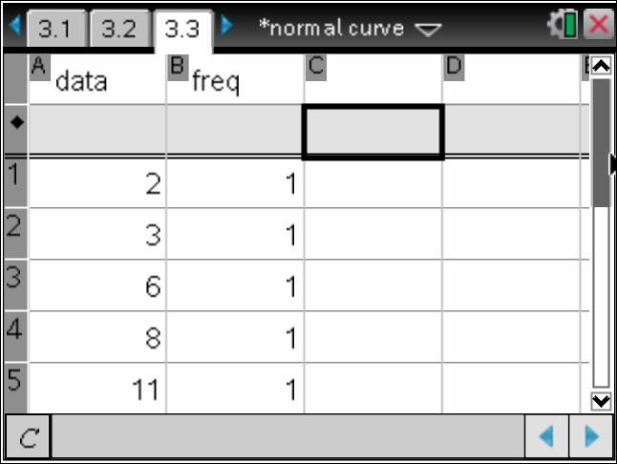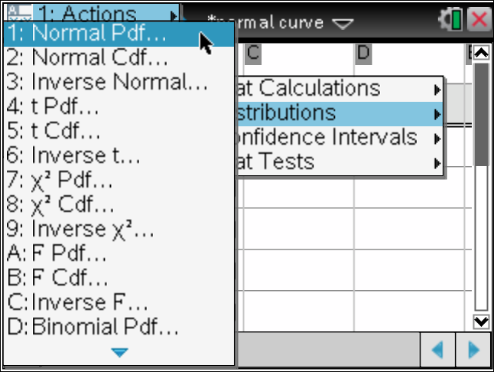

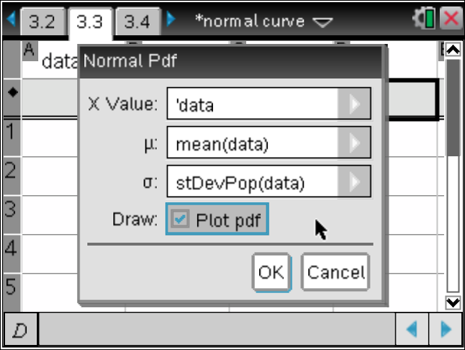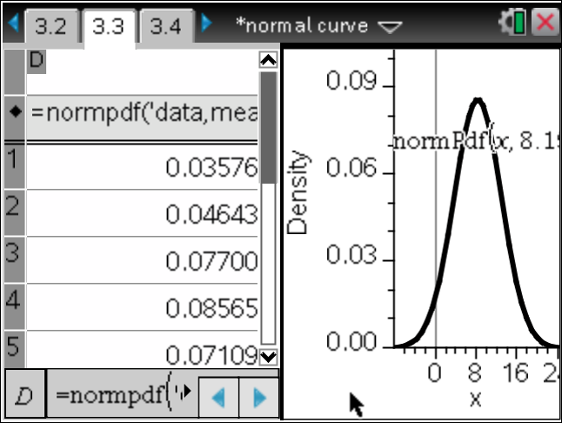

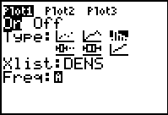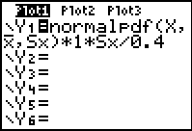

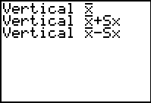

10. What percent of the banana is scab? If the bananas cost (pardon my English) 59 cents per pound, how much are you paying for the part that you eat, assuming that you don’t eat the scab? Compare this True cost per pound to the cost of other vegetables.
11. Do a T-Test on the Density data for both scabbed and scabless bananas using the slope of the line at the True Density. Test at the 95% level.
