Statistics Chapter 11 Part 2 Review Name: __**KEY**______

1. Given the statistical distribution of the table.

|  |  |  |  |  |  |
| --- | --- | --- | --- | --- | --- |
| **x-value** | **61** | **64** | **67** | **70** | **73** |
| **frequency** | **5** | **8** | **18** | **15** | **3** |

**mode: 67  
median: 67 (25th one)  
mean: 67.1837  
Range: 73 to 61 = 12  
Standard deviation  
Sample: 3.20594  
Population: 3.17306**  
2.Giventhe following set of numbers

5, 3, 6, 5, 4, 5, 2, 8, 6, 5, 4, 8, 3, 4, 5, 4, 8, 2, 5, 4.

**mean = 4.8**

**median =5**

**mode = 5**

3.Find the [**variance**](http://www.vitutor.com/statistics/descriptive/variance.html) and [**standard deviation**](http://www.vitutor.com/statistics/descriptive/standard_deviation.html) for the following data series:

12, 6, 7, 3, 15, 10, 18, 5.  
**variance:  
Sample = 27.1429; Population = 23.75   
  
standard deviation:  
Sample = 5.20988; Population = 4.8734**

1. Find the mean, median and mode for the following set of numbers:

3, 5, 2, 6, 5, 9, 5, 2, 8, 6.  
**mean = 5.1  
median = 5   
mode = 5**

1. Find the Standard Deviation and Mean for the following series of numbers:

2, 3, 6, 8, 11, 12, 6, 7, 3, 15, 10, 18, 5.

Use the above information to draw and label a normal curve showing the cutoff points for ± 3standard deviations  
  
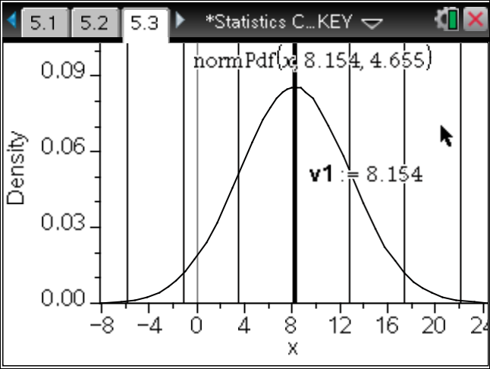

1. Given the series: 3, 5, 2, 7, 6, 4, 9.3, 5, 2, 7, 6, 4, 9, 1.

Calculate **mode:_2,4,5,6,7 median:__5 mean:___ 5.02143___**

**Standard deviation: Sample= 2.54926; Population =2.45653** **quartile 1= 3 and quartile 3 = 7**  
  
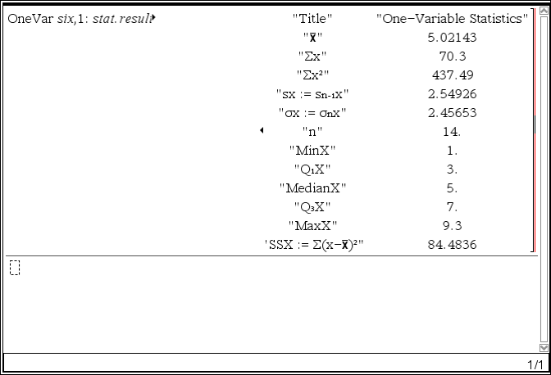 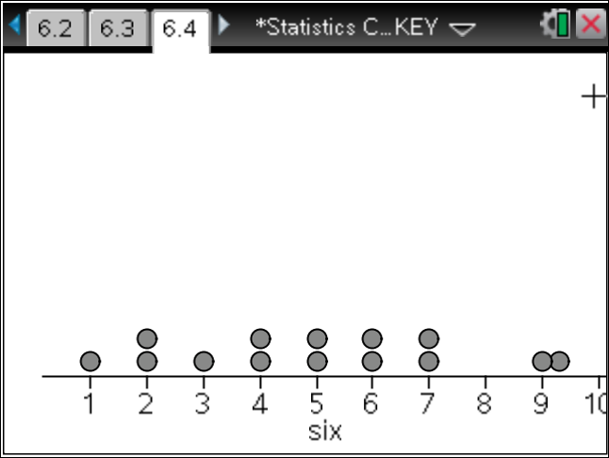

7. Several intelligence tests follow a normal distribution with a mean of 100 and a standard deviation of 15. Draw a normal curve to illustrate the answer.

a. Determine the percentage of the population that would obtain a score between 95 and 110.  
  
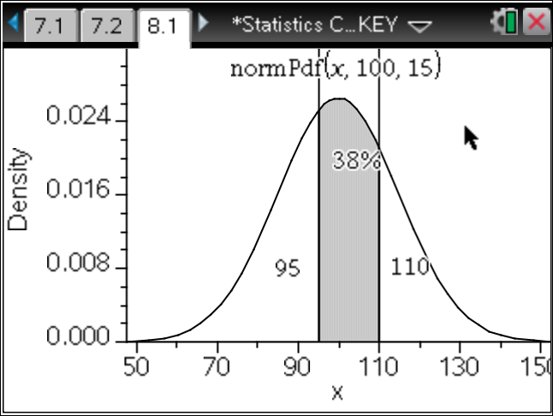

b. What interval centered at a score of 100 contains 50% of the population?  
  
 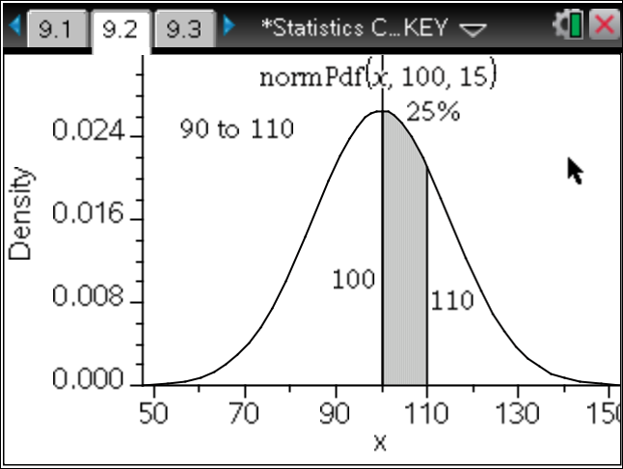

c. For a population of 2,500, how many are expected to have a score above 125?  
**125 folks**  
  
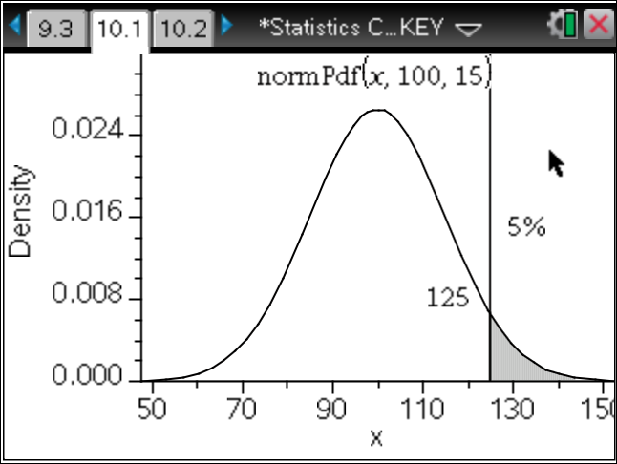

1. In a city, it is estimated that the maximum temperature in June is normally distributed with a mean of 23º and a standard deviation of 5°. Calculate the number of days in this month in which it is expected to reach a maximum of between 18° and 28°. Draw a normal curve to illustrate the answer.

**0.68*30 days = about 20 days**

