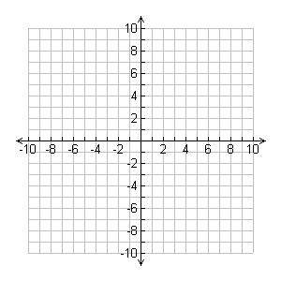
Linear Function Quadratic Function Cubic Function
Equation: _______________ Equation: ______________ Equation: _____________
Absolute Value Function Square Root Function Exponential Function
Equation: _______________ Equation: ______________ Equation:
Reciprocal (or rational) Function Greatest Integer Function
Equation: _______________ Equation: ______________

