Review Worksheet 3.1.- 3.3 Name ______________________
Algebra II

Show work on all problems.

Solve by the substitution method.

1. 2. 3.

Solve by the elimination method.

4. 5.

6. 7.

Classify each system and determine the number of solutions.

8. 9. 10. 11.

Determine if the given ordered pair is a solution to the system.

12. 13.

Complete the table and graph to solve each system.

14. 15.

x | y
0
1
2
3
x | y
0
1
2
3
x | y
o
1
2
3
x | y
o
1
2
3

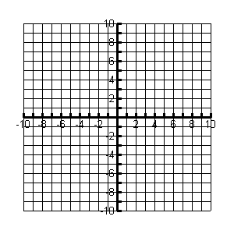
16. Fayetteville Country Club golf course charges $10 to rent golf clubs plus $30 per
hour for golf cart rental. Springdale Country Club golf course charges $15 to rent
clubs plus $25 per hour to rent a cart.

a) Write an system of linear equations to find the number of hours for which the
rental cost is the same.

b) Graph the system.

c) For what number of hours is the cost of
renting clubs and cart the same for each course?

d) How much would it cost for that number of hours?

17. Graph the system of inequalities.

18. Graph the system of inequalities and classify the figure created by the solution
region.

Classify the region as a figure.

________________________

19. A baker is making pastries. He wants to make at least 48 pans of pastries. The
kitchen has two sizes of ovens, one bakes 3 pans at a time and the other bakes 8
pans at a time. The kitchen can use up to 12 ovens at a time. Write a system of
inequalities that can be used to determine how many of each type of oven to use.

