Chapter 5.2 – 5.4 Name:____________________

Pre test Date: __________ Period:____

Use the enclosed graph for numbers 1 and 2

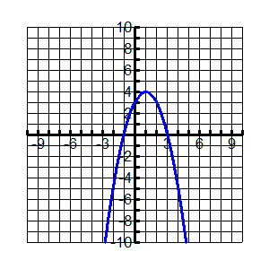

1. What is the range of the function graphed?
2. All real numbers C) y ≤ 4
3. Y ≥ 3 D)
4. The graph shown represents which quadratic function?
5. 
6. 
7. 
8. 
9. Which equation represents the axis of symmetry for the equation 
10. x = – 4 B) x = 1 C) x = 2 D) x = 5
11. Which function has – 7 as its only zero?
12.  C) 
13.  D) 
14. Complete the square for the resulting expression and identify the resulting expression as a binomial squared
15.  C) 
16.  D) 
17. Solve the equation. 
18.  B)  C)  D) 
19. Identify the zero of the function: 
20. 3, – 5 B) – 3, 5 C) 3, 5 D) – 3, – 5
21. A golfer hits a ball from ground level with an initial velocity of 80 ft/s. After how many seconds will the ball hit the ground?
22. After 3 seconds C) after 4 seconds
23. After 5 s D) after 6 seconds
24. Find the length and width of the given rectangle X + 16
25. L= 20 W = 4 C) L = 16 W = 5 X

A = 80 ft 2

1. L = 40 W = 2 D) L = – 16 W = 4
2. Identify the roots of the equation  using factoring.
3. x = 2 or x = 7
4. x = – 2 or x = 7
5. x = 2 or x = – 7
6. x = – 2 or x = – 7