Sections 6.5-6.6 Worksheet Algebra 2 Name _______________________
Period ______

Solve by factoring. Identify the roots of each equation, stating the multiplicity of each root if more than one.

1. 2. 3.

4. 5. 6.

7. 8. 9.

Solve following the equations. Start by factoring, then use the quadratic formula where needed to find all complex roots of the equation.

10. 11. 12.

13. 14. 15.

Not all polynomials are factorable, but the Rational Root Theorem can help you find all possible rational roots of a polynomial equation. List the candidates for rational zeros.

16. 17.

Possible numerators: ________________________ Possible numerators: ________________________
Possible denominators: ______________________ Possible denominators: ______________________

Possible rational zeros: ______________________ Possible rational zeros: _______________________

18. 19.

Possible numerators: ________________________ Possible numerators: ________________________
Possible denominators: ______________________ Possible denominators: ______________________

Possible rational zeros: ______________________ Possible rational zeros: _______________________

Find the remaining complex roots of the following equations when given one of the roots. Use synthetic division to get the depressed polynomial, then use the quadratic formula.

20. , 21. ,

_________________ _________________

22. , 23. ,

___________________ _________________

24. , 25. ,

___________________ ___________________

A polynomial function with rational coefficients has the given zeros. Use these zeros to a) write the factors of a polynomial function, then b) write the equation of the polynomial function in standard form.

26. 27. 28.

a)_____________________ a)______________________ a)_______________________

b)_____________________ b)______________________ b)_______________________

29. 30. 31.

a)_____________________ a)______________________ a)_______________________

b)_____________________ b)______________________ b)_______________________

Use the graph to locate the roots and the multiplicity of the roots then write the equation of the graph.
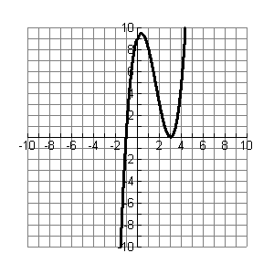
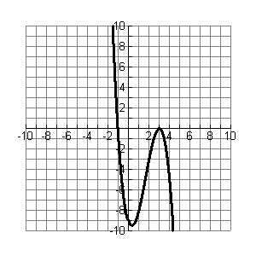
32. 33.

Roots: ____________________________ Roots: ____________________________

Equation of the graph ___________________ Equation of the graph ___________________

