Review Chapter 8.1 - 8..4 ALGEBRA 2 Name ______________________

- The dollar amount d that Jane earns varies directly as the number of hours t that she works. If d = $115.35 when t = 15 find t when d = 438.33

2. Determine whether the following data set represents a direct or inverse variation.

x | 2.7 | 61.2 | 41.4
y | 3 | 68 | 46

Multiply or Divide. Assume that all expressions are defined.

3.

4.

5.

Find the least common multiple for each pair.

6. 7.

Simplify . Assume that all expressions are defined.

8. 9.

Add or subtract. Assume all expressions are defined.

10.

11.

12.

13.

14. Use f(x) = to find the following: Accurately graph the function. If there is no answer to the blank, write “none”.

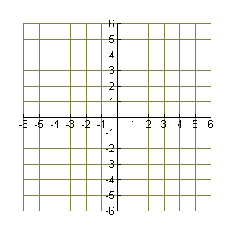
Domain __________________

Range ____________________

x-intercept(s) _____________

y-intercept _________________

horizontal asymptote __________

vertical asymptote(s) ______________

hole in the graph at x = ________

