Section 7.3 Algebra 2 Name ________________________ Period ______
Worksheet

Evaluate each of the following.

1. 2. 3.

4. 5. 6.

7. 8. 9.

10. 11. 12.

Change the following from exponential form to logarithmic form.

13. 14.

15. 16.

17. 18.

Change the following from logarithmic form to exponential form.

19. 20.

21. 22.

23. 24.
25. Graph and graph its inverse on the same graph. Then find the following characteristics about each graph. Write “none” is it doesn’t exist.

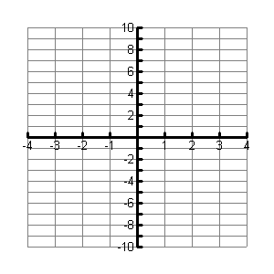

Domain ________ Domain _________

Range _________ Range __________

x-intercept ______ x-intercept ______

y-intercept ______ y-intercept ______

Equation of Equation of
asymptote ________ asymptote _________

End behavior End behavior

26. Graph and graph its inverse on the same graph. Then find the following characteristics about each graph. Write “none” is it doesn’t exist.

Domain ________ Domain _________

Range _________ Range __________

x-intercept ______ x-intercept ______

y-intercept ______ y-intercept ______

Equation of Equation of
asymptote ________ asymptote _________

End behavior End behavior

