Radians, Degrees, and the Unit Circle
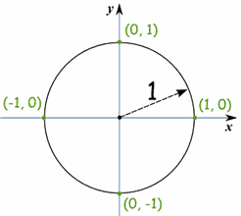 | The "Unit Circle" is just a circle with a radius of 1.  The center is put on a graph where the x axis and y axis cross, so we get this neat arrangement here.

In science and engineering, radians are much more convenient (and common) than degrees. A radian is defined as the angle between 2 radii (radiuses) of a circle where the arc between them has length of one radius.
Another way of putting it is: "a radian is the angle subtended by an arc of length r (the radius)".
One radian is about 57.3°. 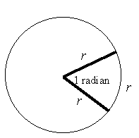

Because the circumference of a circle is given by C = 2πr and one revolution of a circle is 360°, it follows that:
2π radians = 360°.
This gives us the important result: π radians = 180°
From this we can convert:
radians → degrees and degrees → radians.

Name: ___________

Worksheet for Radians & Degrees

I. Converting Degrees to Radians:
Example: What is 30° in radians?
Solution:

Problems: Convert to Radians

- 45°

- 60°

- 52°

- 90°

- 120°

- 72.5°

- 307°

8) 293°

9) 180°

10) 145°

II. Converting Radians to Degrees:
Example: What is 2 rad. in degrees?
Solution: So 2 rad is 114.592°.

Problems: Convert to Degrees

- π/3

- π/4

- π/6

4) 3π/4

5) 4π/3

6) π

7) 5π

8) π/10

9) 3

10) 5

