Section 9.2 Algebra 2 Name ____________________
Piecewise Functions Worksheet Period ______

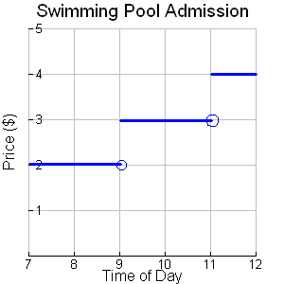
1. Create a table and a verbal description to represent the graph.

Price | Time of day

__________________________________

__________________________________

Evaluate the following step function for the following values.

2. f(-6)= ____ f(-4)=_____ f(2)= _______ f(5)= _______

3. Graph the function used in problem number 2.
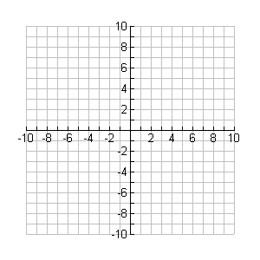
Graph the following piecewise functions. Then evaluate the following.

4.

g(2) = _____

g(-3) = _____

g(0) = _____

5.

h(-3)=_______

h(-2)=______

h(2)=_______

h(5)=_______

6.

f(2)=_______

f(-3)=______

f(-1)=_______

f(0)=_______

