Review C for Spring 2013 Final Exam Algebra 2 Name __________________________

**Multiple Choice Practice**

1 The function is a growth or decay? Choose the graph of the function.

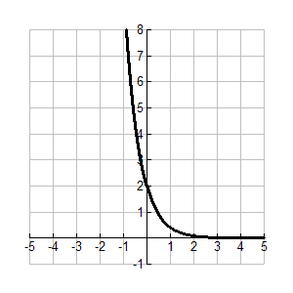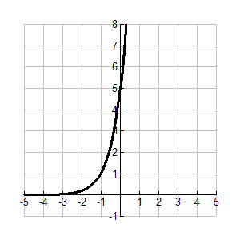 a. This is an exponential growth function. c. This is an exponential decay function.

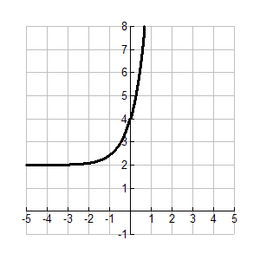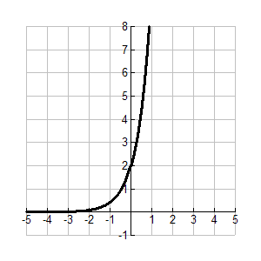 b*.* This is an exponential growth function. d. This is an exponential growth function.

2. Write the exponential equation in logarithmic form.

a.  b.  c.  d. 

3. Write the logarithmic equation  in exponential form.

a.  b*.*  c.  d. 

4. A bacteria population starts at 3,000 and decreases at about 12% per day. Write a function representing the

number of bacteria present each day. After how many days will there be fewer than 500 bacteria?

a.  b.  c.  d. 

5. The amount of money in a bank account can be expressed by the exponential equation 

where *A* is the amount in dollars and *t* is the time in years. About how many years will it take for the

amount in the account to be more than $900?

a. 3 years b. 19 years c. 35 years d. 121 years

6. Solve . Check your answer.

a.  b.  c.  d. no solution

7. Simplify the expression . Assume that all variables are positive.

a.  b.  c.  d. 

8. Write the expression  in radical form, and simplify. Round to the nearest whole number if necessary.

a.  b.  c.  d. 

9. Write the expression by using rational exponents.

a.  b.  c.  d. 

10. Solve .

a.  b.  or  c.  d. no solution

11. Solve 

a. x = 27 b.  c. x =  d. no solution

12. Given  and , find .

a.  b.  c.  d. 

13. Given  and , find .

a.  c*.* 

b.  d. 

14. Given  and , find .

a. 25 b. 36 c. 28 d. 19