1. Simplify .

a.  b.  c.  d. 

1. Solve the equation .

a.  b.  c.  d. no solution

3. Solve for x 

a.  b.  c.  d. 

1. Add: Assume that all expressions are defined.



a.  b.  c.  d. 

1. Subtract: 

a.  b.  c.  d. 

1. Divide and simplify. Assume that all expressions are defined.



a.  b.  c.  d. 

1. For the following function, identify the vertical asymptote:



* 1.  b.  c.  d. 

1. The function  has a hole in the graph when x = ____?
   1. 2 b. - 2 c. 4 d. - 4

9. Solve the equation or formula for the indicated variable. , for *t.*

a.  b.  c.  d. 

1. Solve.  Check your answer.

a.  b.  c.  d. no solution

1. Solve: 

a. 22, 11 b. 22 c. 11 d. no real number solution

12.



a. b. c. d. Won’t simplify



1. Write the expression  in radical form, and simplify. Round to the nearest whole number if necessary.

a.  b.  c.  d. 

14. Which of the following is equal to ?

a.  b.  c.  d. 

15. 

a.  b.  c.  d. 

16. Which value is equivalent to ?

a.  b. 6 c. 8 d. 24

17. Write the expression below using rational exponents. 

a.  b.  c.  d. 

18. Which of the following is equal to ?

a.  b.  c.  d. 

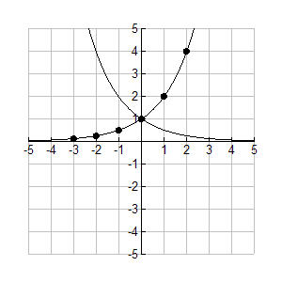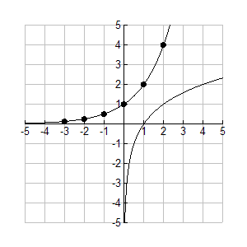19. Use  to graph the function . Choose the graph of the function and the inverse function.

a*.* b.

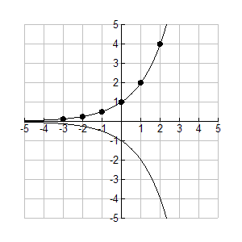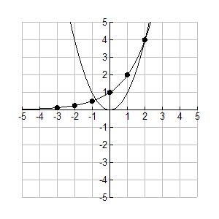

c. d.

20. The amount a spring will stretch, S, varies directly with the force (or weight), F, attached to the spring. If a spring stretches 1.19 inches when 11.9 pounds is attached, how far will it stretch when 12 pounds is attached?

a. 1200 in. b. 0.1 in. c. 1 in. d. 1.2 in.

21. Which of the following is a direct variation equation?

a.  b.  c.  d. 

22. The chart of the following represents which type of variation?

|  |  |  |  |  |
| --- | --- | --- | --- | --- |
| X | 3.75 | 15 | 5 | 2 |
| Y | 12 | 3 | 9 | 22.5 |

a. closed b. direct c. neither d. inverse

23. Write the inverse of .

a.  b.  c.  d. 

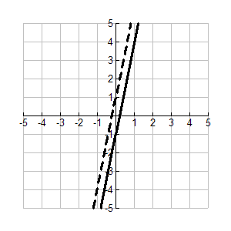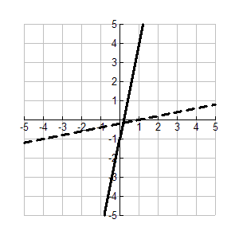24. The solid line graphs the function . Choose the dashed line that graphs its inverse.

a. b.

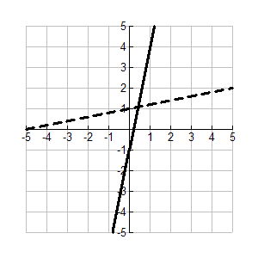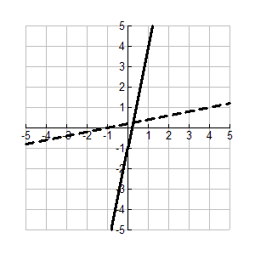

c. d.

25. Given  and , find .

a.  b.  c.  d. 

26. Given  and , find .

a.  b*.* 

c.  d. 

27. Given  and , find .

a. 108 b. 405 c. 3,375 d. 111

1. Which is the correct graph of the function  ?

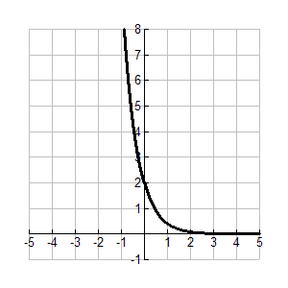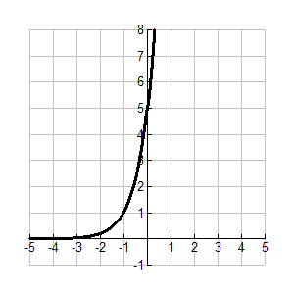 a. b.

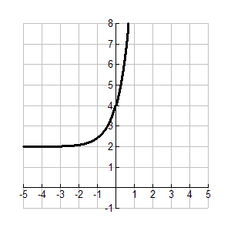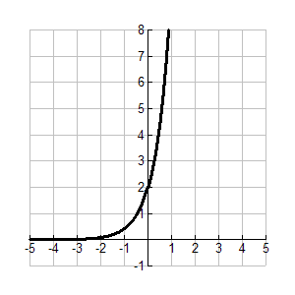 c*.* d.

1. Write the exponential equation in logarithmic form.

a.  b.  c.  d. 

1. Write the logarithmic equation  in exponential form.

a.  b*.*  c.  d. 

1. Which of the following shows the equation written in logarithmic form?



1. b. c. d.



1. A bacteria population starts at 2,032 and decreases at about 15% per day. Write a function representing the number of bacteria present each day.

a.  b.  c.  d. 

1. The amount of money in a bank account can be expressed by the exponential equation , where *A* is the amount in dollars and *t* is the time in years. About how many years will it take for the amount in the account to be more than $900?

a. 30 years b. 19 years c. 37 years d. 221 years

1. Which exponential function below models a population of 100 frogs decreasing at an annual rate of 8%?

a.  b.  c.  d. 

35. Choose the function that shows exponential growth.

a.  b.  c.  d. 

36. Convert to radians:



1. b. c. d.



37.Convert 5.3 radians to degrees:

1. 0.09° b. 0.18° c. 151.83° d. 303.67°
2. Evaluate the following: 
3. 1 b.  c.  d. 
4. If the radian measure for an angle is , then the degree measure for is:



1. 150° b. -216° c. 36° d. -150°
2. Evaluate the following: 
3. 1 b.  c.  d. 

41. Evaluate the following:



* 1. 1 b.  c.  d. 

1. Which of the following sets of data has a median of 17.5?
   1. {10.0, 17.5, 14.0, 16.0, 27.5} b. {12.5, 26.0, 17.5, 11.5, 10.5}
2. {13.0, 17.5, 15.0, 15.5, 17.5} d. {14.5, 19.5, 16.0, 17.5, 24.2}

43. The number of hours daily that Austin spent reading during one week are shown below.

|  |
| --- |
| 1.5 4.25 1.0 3.75 6.0 0.75 0.25 |

What is the mean number of hours per day that he spent reading for this week?

1. 1.5 b. 2.5 c. 3.75 d. 5.75
2. The mean of four numbers is 70. When a fifth number is included, the mean of the five numbers is 80. What is the fifth number?
3. 40 b. 90 c. 120 d. 250
4. The middle value of an ordered array of numbers is the
5. Mean b. median c. mode d. midpoint

|  |  |
| --- | --- |
| NUMBER | OCCURRENCES |
| 1 | 6 |
| 2 | 11 |
| 3 | 19 |
| 4 | 14 |

1. The table shows the results of a spinner experiment. Find the probability of spinning a number greater than 2.

1. b. c. d.



1. The average value of a set of numbers is the
2. Mean b. median c. mode d. midpoint
3. The numbers 1-25 are written on paper slips and placed in a container for a drawing. Dakota reaches in to randomly select a winning number. What is the probability he chooses a multiple of 2 or a multiple of 5?
   1. b. c. d. 1



1. A coin is flipped 3 times. What is the probability that the result is tails all three times?
   1. b. c. d.



1. A bookstore is stocking different varieties of new books. The number of each type of book is shown in the table. If a book is chosen at random from this group, what is the probability that the book is a horror or action novel?

|  |  |  |  |  |
| --- | --- | --- | --- | --- |
| Type of Book | Mystery | Horror | Action | Romance |
| Number of Books | 7 | 5 | 7 | 5 |

1. b. c. d.

