Algebra II Exam A Review Name:_____________________________ Period_____

1. Identify each of the following graphs as representing an exponential function that is either growth, decay, or neither of those. Write “growth”, “decay”, or “neither” in the space below each graph.

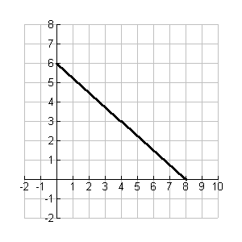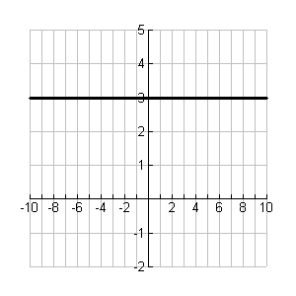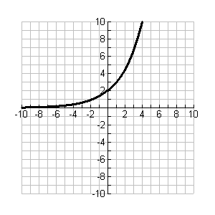

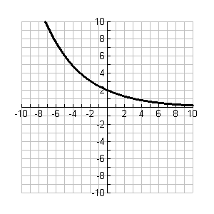________________ _______________ ______________ ________________

1. Evaluate the following logarithms.

A)  = ______ B)  = _______ C)  = _______ D) = _________

1. Write “Yes” by each of the following problems that can be modeled for values using exponential functions. Write “No” by those for which an exponential model would not be appropriate.

________ A sample of a radioactive element is decaying with a half-life of 19 days. Let t = the number of days that have passed and f(t) = the mass of the element that is radioactive.

________ Mary Lynn makes $8.25 per hour working on her job. Let t = the hours she works and f(t) = the amount of her paycheck before deductions.

_______ The colony of bacteria is averaging 6% growth per day. Let t = the number of days that have passed and f(t) = the number of bacteria.

1. Identify each of the following as being exponential growth, exponential decay, or neither.

A)  _____________________ B) _____________________

1. When  is converted to logarithmic form it would be ___________________________
2. When  is converted to exponential form it would be _______________________
3. Which of the following is a true statement about the end behavior of  ?

A)  C) 

B)  D) 

1. Shown below is the graph of the exponential function. Which of the choices would be the graph of this function’s inverse?

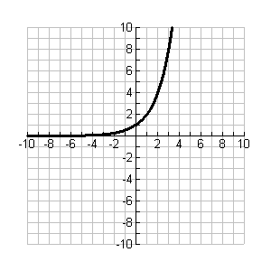

A) 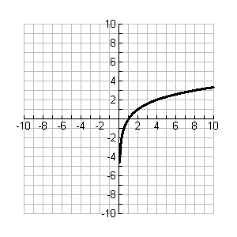B) 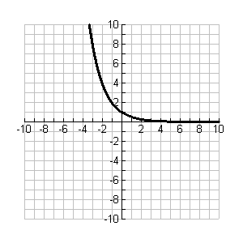 C) 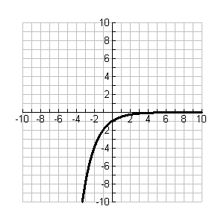D)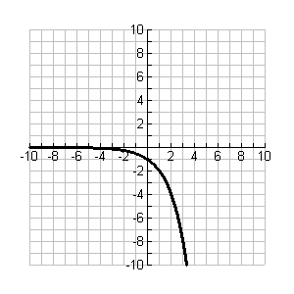

1. For the exponential graph shown below identify the domain, range, intercepts, asymptotes, and end behavior in the blanks provided. Write “none” if that is the case.

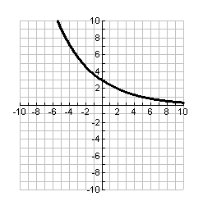

A) Domain _________________________

B) Range __________________________

C) Y-intercept ______________________

D) X-intercept ______________________

E) End behavior

_________________

_________________

1. Gina buys a car for $13,500. Assume that its value will decrease by about 15% each year. 
2. Write an exponential function to model the value of the car. _____________________
3. What will the value be after 4 years?__________________________
4. Use the formula  to compute the total amount for an investment of $1000 at

3.5% interest compounded continuously for 5 years.

1. Evaluate  . Round to the nearest hundredth.

1. Simplify. .
2. Simplify. .

1. Simplify. 