Exponential Functions Algebra 2 Name __________________________

Worksheet #1 Date ___________ Period ______

1. A car that was purchased for $30,000 depreciates about 15% per year.
   * 1. Is this an exponential growth or decay function? Explain.
     2. Write the formula of the function.
     3. Graph the function.
     4. What is the x-intercept for this function? What does it mean in the context of this problem?
     5. What is the y-intercept for this function? What does it mean in the context of this problem?
     6. What is the domain for this function? What does it mean in the context of this problem?
     7. What is the range for this function? What does it mean in the context of this problem?
     8. Describe the end behavior of the function using infinity notation.
     9. Find the value of the car after 5 years.
2. Radon-222 is a gas that escapes from rocks and soil. It can accumulate in buildings and can be dangerous for people who breathe it. Radon-222 decays 17% each day.



1. Is this an exponential growth or decay function? Explain.
2. Write the formula of the function.
3. Graph the function.
4. What is the x-intercept for this function? What does it mean in the context of this problem?
5. What is the y-intercept for this function? What does it mean in the context of this problem?
6. What is the domain for this function? What does it mean in the context of this problem?
7. What is the range for this function? What does it mean in the context of this problem?
8. Describe the end behavior of the function using infinity notation.
9. Find the number of days it takes for 500 mg of Radon-222 to decay to under 40 mg.
10. John invested $9000 at 5.5% interest compounded quarterly (4 times per year) for 12 years.

r = interest rate in decimal form,



where n = number of compounding periods per year

t = number of years the money is invested.



* 1. Is this an exponential growth or decay function? Explain.
  2. Write the formula of the function.
  3. Graph the function.
  4. What is the x-intercept for this function? What does it mean in the context of this problem?
  5. What is the y-intercept for this function? What does it mean in the context of this problem?
  6. What is the domain for this function? What does it mean in the context of this problem?
  7. What is the range for this function? What does it mean in the context of this problem?
  8. Describe the end behavior of the function using infinity notation.
  9. Find the amount he will have at the end of 12 years.
  10. How many years will John have to wait until his investment is worth at least $80,000?

1. 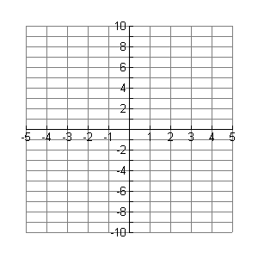Fill in the function values in the table, then graph the function 

|  |  |  |  |  |  |  |  |
| --- | --- | --- | --- | --- | --- | --- | --- |
| x | -3 | -2 | -1 | 0 | 1 | 2 | 3 |
| f(x) |  |  |  |  |  |  |  |

1. What is the x-intercept? _________
2. What is the y-intercept? _________
3. Is this function exponential growth, exponential decay, or neither? ___________________
4. What is the domain of this function? ______________________
5. What is the range of this function? ______________________
6. Describe the end behavior using infinity notation.

$x→-∞, f\left(x\right)→___________$ $x→-∞, f\left(x\right)→___________$

Tell whether the function is exponential growth, exponential decay, or neither.

5.  6.  7.  8. 

__________________ __________________ __________________ __________________

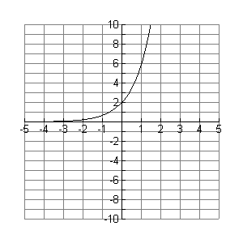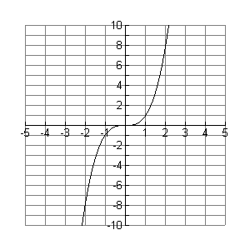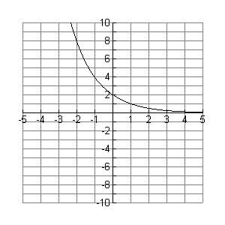9. Label which graph is exponential growth, which graph is exponential decay, and which graph is neither.

____________________ ____________________ ____________________

1. Fill in the function values in the table, then graph the function 



|  |  |  |  |  |  |  |  |
| --- | --- | --- | --- | --- | --- | --- | --- |
| x | -3 | -2 | -1 | 0 | 1 | 2 | 3 |
| f(x) |  |  |  |  |  |  |  |

What is the x-intercept? _________

What is the y-intercept? _________

What is the domain of this function? ______________________

What is the range of this function? ______________________

Describe the end behavior using infinity notation.