# Worksheet 8.4 Practice Algebra 2 Name____________________

Period _____

**If there is no answer to the blank on this worksheet, write “none”.**

1. Use  to find the following: Accurately graph the function.

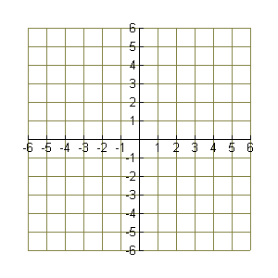

Domain __________________

Range ____________________

x-intercept(s) _____________

y-intercept _________________

horizontal asymptote __________

vertical asymptote(s) ______________

hole in the graph at x = ________

1. 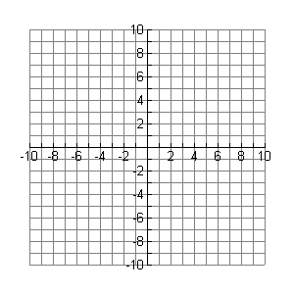Use to find the following Accurately graph the function.

Domain ________________

Range ____________________

x-intercept(s) _____________

y-intercept _________________

horizontal asymptote __________

vertical asymptote(s) ______________

hole in the graph at x = _________

1. Use  to find the following: Accurately graph the function.



Domain __________________

Range ____________________

x-intercept(s) _____________

y-intercept _________________

horizontal asymptote __________

vertical asymptote(s) ______________

hole in the graph at x = ________

1. Use  to find the following: Accurately graph the function.



Domain __________________

Range ____________________

x-intercept(s) _____________

y-intercept _________________

horizontal asymptote __________

vertical asymptote(s) ______________

hole in the graph at x = ________