# Review Chapter 8.1 - 8..4 ALGEBRA 2 Name ______________________

Multiply or Divide. Assume that all expressions are defined.

1. 

2. 

3. 

Find the least common multiple for each pair.

4.  5. 

Simplify . Assume that all expressions are defined.

6.  7. 

Add or subtract. Assume all expressions are defined.

8. 

9. 

10. 

11. 

12. Use f(x) = to find the following: Accurately graph the function. If there is no answer to the blank, write “none”.

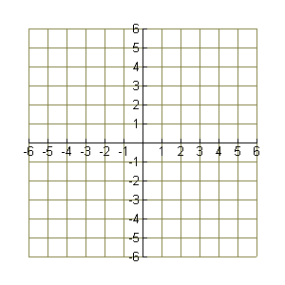

Domain __________________

Range ____________________

x-intercept(s) _____________

y-intercept _________________

horizontal asymptote __________

vertical asymptote(s) ______________

hole in the graph at x = ________