Algebra 2
Review Worksheet #1 for 5.1-5.2

1)
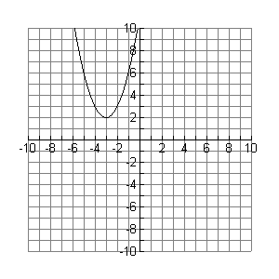
Vertex __________ Axis of Symmetry __________

Transformations from
____________________ ____________________

Opens up or down? Max or Min? Max or Min value _____

Domain ____________ Range ______________

Equation of the graph _______________________

2)
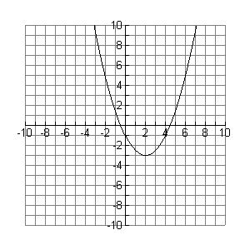
Vertex __________ Axis of Symmetry __________

Transformations from

__________________ ________________ _________________

Opens up or down? Max or Min? Max or Min value _____

Domain ____________ Range ______________

Equation of the graph _______________________

3)
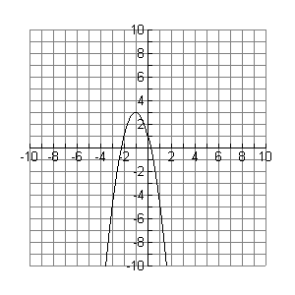
Vertex __________ Axis of Symmetry __________

Transformations from

__________________ ________________ _________________

Opens up or down? Max or Min? Max or Min value _____

Domain ____________ Range ______________

Equation of the graph ________________________

4)

Vertex __________ Axis of Symmetry __________
Transformations from Opens up or down?

_____________________ ______________________ Max or Min? Max or Min value _____

Domain ____________ Range ______________ Y-Intercept __________

5)

Vertex __________ Axis of Symmetry __________

Transformations from Opens up or down?

_____________________ ______________________ Max or Min? Max or Min value _____

Domain ____________ Range ______________ Y-Intercept __________

6)

Vertex __________ Axis of Symmetry __________
Transformations from Opens up or down?

_______________ _______________ _______________ Max or Min? Max or Min value _____

Domain ____________ Range ______________

7)
Vertex __________ Axis of Symmetry __________
Transformations from Opens up or down?

_______________ _______________ _______________ Max or Min? Max or Min value _____

Domain ____________ Range ______________

8)

Vertex __________ Axis of Symmetry __________
Transformations from Opens up or down?

_______________ _______________ _______________ Max or Min? Max or Min value _____

Domain ____________ Range ______________

