Test Review 5.5, 5.6, 5.7, 5.9 Algebra 2 Name _________________________

Simplify. Express each number in terms of i.

1. 2.

Solve each equation.

3. 4.

Find each complex conjugate.

5. 6.

Find the value of the discriminant (), the number of solutions, and the type of solutions.
7. 8. 9.

Find the zeros of the function by using the Quadratic Formula.
10. 11.

12. 13.

Determine whether the ordered pair is a solution of the inequality. Show your work

14. , 15. , 16. ,

Solve each quadratic inequality algebraically, then graph the solution on a number line.

17. 18. 19.

Graph each quadratic inequality.

20. 21. 22.

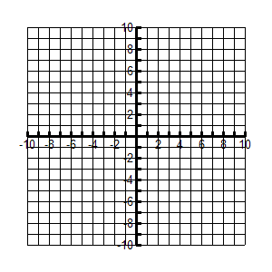

Determine the Absolute Value of the Complex Number.

23. 24. 25.

Add and Subtract the Complex Number.

26. 27. 28.

Multiply or simply the complex number.

29. 33. 31.

