1. Identify all of the roots of the equation by factoring, using the Rational Root Theorem and synthetic division to find a depressed polynomial that can be solved by using the quadratic formula. State the multiplicity of each root, if more that one.
a. b.

c. d.

2. Solve by finding all roots by using the calculator to find as many rational roots as possible, then use synthetic division and the quadratic formula to find the remaining roots. Show all work!

3. Write factors of the simplest polynomial function with rational coefficients that has the given zeros, then multiply out the factors to give the polynomial function in standard form.

a. 5, 1, -1 a. factors: __________ __________ __________

polynomial function: f(x) = ___________________

b. 1, b. factors: __________ __________ __________

polynomial function: f(x) = ___________________

c. c. factors: __________ __________ __________

polynomial function: f(x) = ___________________

Classify each of the graphs of the polynomial functions below by their degree and leading coefficient.
Then determine the end behavior of each graph.

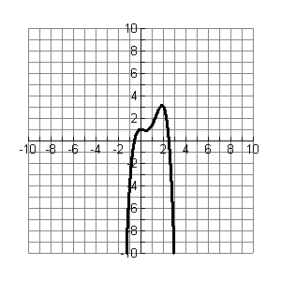
4. 5. 6. 7.
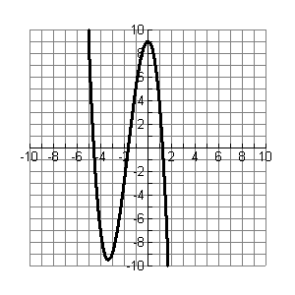
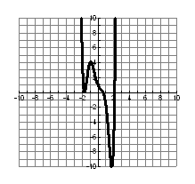
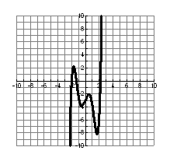
Circle the correct choice.
Degree: Even or Odd Degree: Even or Odd Degree: Even or Odd Degree: Even or Odd

Leading Coefficient is Leading Coefficient is Leading Coefficient is Leading Coefficient is
Positive or Negative Positive or Negative Positive or Negative Positive or Negative

Match the polynomial equation with its end behavior.

8. ____ A.
9. ____ B.
10. ____ C.
11. ____ D.

12. Solve each polynomial equation by factoring.
a. b. c.

13. Use the Rational Root Theorem to list all the possible rational roots of the polynomial equation.
0

14. Use your graphing calculator to estimate the real zeros, local maximum, and local minimum of
. Round your answers to the nearest thousandth.

real zeros __________, __________, ___________ maximum _________ minimum _________

15. Which polynomial function with rational coefficients has zeros ?
A. B. C. D.

16. A polynomial function of degree n has at most _________ turning points (local maxima and local minima)
and at most _______ x-intercepts.

17. In each box, sketch a graph of a polynomial function that fits the description.

Leading coefficient | Odd degree | Even degree
Positive
Negative

18. Determine the best Polynomial Function for the given data using Finite Differences and give the r² value.
Time | 2 | 4 | 6 | 8 | 10 | 12 | 14 | 16 | 18
Velocity | 24.51 | 16.44 | -8.91 | -59.70 | -142.56 | -262.57 | -423.28 | -626.71 | -873.34

