Identify whether the function graphed has an even or odd degree. Then state if the leading coefficient of the polynomial function is positive or negative.

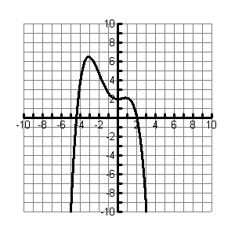
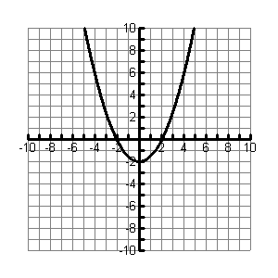
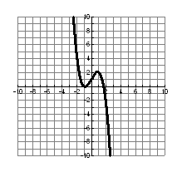
1. 2. 3. 4.
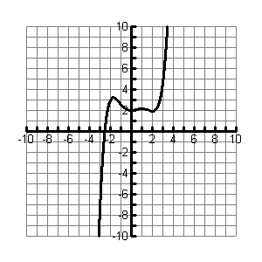
degree ______ degree ______ degree ______ degree ______

Is the leading coefficient Is the leading coefficient Is the leading coefficient Is the leading coefficient
positive or negative? positive or negative? positive or negative? positive or negative?

5. Matching Use the numbers from the graphs of the problems (#1 - #4) above that have the following end behavior.

a. a. _______

b. b. _______

c. c. _______

d. d. _______

6. Describe the end behavior of each function by completing the statements.

a. a.

b. b.

7. Let . Write a function g that performs each of the following transformations.

- Reflect f across the y-axis. A. ________________________________

B. Reflect f across the x-axis. B. ________________________________

8. Let . Write the rule for each function

A. A. _______________________________

B. B. _______________________________

Matching Match the description of function g as a transformation of function f.

_____ 9. A. Vertical compression

_____ 10. B. Horizontal compression

_____ 11. C. Vertical stretch

_____ 12. D. Horizontal stretch

13. Find the local maximum and local minimum for .

Round to the nearest tenth. Max ________ Min _________

