Section 6.5 Worksheet Algebra 2 Name_________________________
Multiplicity of zeros Period ______

Graphs of equations that have zeros with multiplicity of 1 pass directly through the x-axis. Graphs of even multiplicities of zeros "touch" the x-axis and reverse direction. Graphs of odd multiplicities greater than or equal to 3 have a "point of inflection" on the x-axis and "bend" before and after crossing the x-axis.

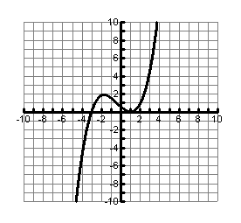
1. Identify the zeros of each graph. State the multiplicity of each zero, then write an equation that shows the multiplicity of the zeros.
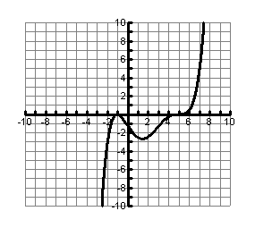

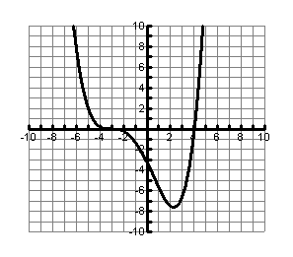
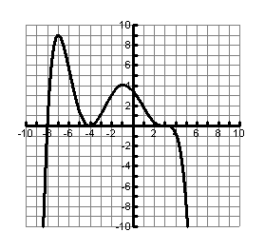

2. Graph the following polynomial functions. Identify the zeros of each equation, stating the multiplicity.
a. b.

