Worksheet 8.4 Practice Algebra 2 Name____________________
Period _____

If there is no answer to the blank on this worksheet, write “none”.

- Use to find the following: Accurately graph the function.
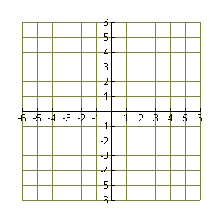
Domain __________________

Range ____________________

x-intercept(s) _____________

y-intercept _________________

horizontal asymptote __________

vertical asymptote(s) ______________

hole in the graph at x = ________

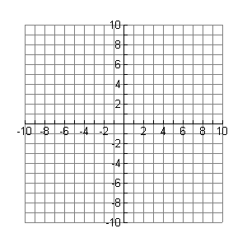
- Use to find the following Accurately graph the function.
Domain ________________

Range ____________________

x-intercept(s) _____________

y-intercept _________________

horizontal asymptote __________

vertical asymptote(s) ______________

hole in the graph at x = _________

- Use to find the following: Accurately graph the function.
Domain __________________

Range ____________________

x-intercept(s) _____________

y-intercept _________________

horizontal asymptote __________

vertical asymptote(s) ______________

hole in the graph at x = ________

- Use to find the following: Accurately graph the function.
Domain __________________

Range ____________________

x-intercept(s) _____________

y-intercept _________________

horizontal asymptote __________

vertical asymptote(s) ______________

hole in the graph at x = ________

