Review II 9.2, 9.4 and 9.5 Name__________________________
Period ______

Evaluate each piecewise function for the following.

1. f(-4)= ______ f(-3)= ______ f(3)= ______ f(6)= ______

2. g(-4)= _______ g(3)= _______ g(6)= _______

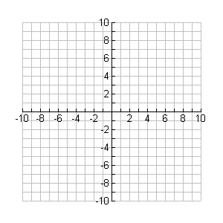
Graph each function.

3.

4.

Review Page 2

Given: and , find each function.

5. =_______________________

6. =______________________

7. =______________________

Given: and , find each function. State the domain of each.

8. = _______________________ Domain ____________________

9. =_______________________ Domain ____________________

10. =_______________________ Domain ____________________

Given: and , find each value.

11. =___________ 12. =___________ 13. =__________

Given: and , find each function. State the domain of each.

14. Domain of = _______________ Domain of = ___________________

Write the composition function = _______________________

Then state the domain of ______________________

Review Page 3

Find the inverse of each function using inverse function notation. Determine whether the inverse is a function and state its domain and range.

15.

Inverse __________________ Is the inverse a function? Yes/no ________

Domain____________ Range____________

16.

Inverse__________________ Is the inverse a function? Yes/no________

Domain____________ Range____________

17.

Inverse __________________ Is the inverse a function? Yes/no ________

Domain____________ Range____________

18.

Inverse__________________ Is the inverse a function? Yes/no________

Domain____________ Range____________

Determine by composition whether these functions are inverses. Show all work.
19. and

