Algebra II Goals
This course is designed to instill in the student an understanding in, and prowess with, algebraic thinking as preparation for using mathematics in future school and work experiences. The key aspects of this course are related to the Common Core State Mathematics Standards and the Standards for Mathematical Practice as listed below.

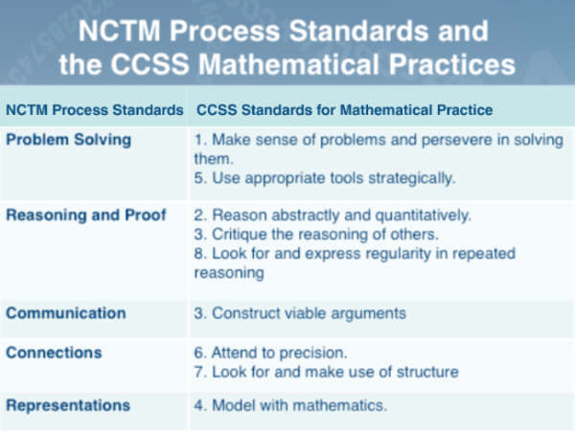

Students who successfully complete this course will be well prepared to continue their study of mathematics at FHS. The majority of students in this course should plan to move on to take more mathematics to facilitate their access to a successful life of work.

More information about Mr. Young’s Algebra II course may be discovered at:
http://militantgrammarian.com/DAY/ALGII/AlgebraII1112.htm

Expectations
Students in the course will be responsible for knowing and following the Fayetteville Computer and Network Use Policies that can be found at http://www.fayar.net/DistrictPolicies/Pol4100/Pol4202.pdf
as well as the guidelines in the FHS Student Handbook.

I would like to have at least two contacts with your parents this year. Please encourage them to attend our Open House and other conferences through the year.

What Technology will be used?
Hardware:
TI-84/83 Plus, TI-NSprire CAS; Graph Link; Digital Camera; TI-Navigator; and Calculator Based Data Collection with various probes.
Software:
FireFox, Windows XP, VideoPoint, TI-NSpire CAS, Qdysseyware, Graph Link; TI Connect; Graphical Analysis, Interactive Physics, TI Interactive!, GSP, and Microsoft Office.
Grades
Your grade will be calculated each semester using the scores from the following (weighted as shown):
- Examinations (50%)*
- Quiz (20%)
- Homework (20%)#
- Journal (10%)

* Any student may complete a review plan with their teacher and then retest. The higher grade will be used for the grade on that exam. The retest will be scheduled by Mr. Young and must be taken in a timely manner.
# Homework will always be picked up and graded. The grading will be a sampling of the practice items. It is important that you do homework, but if you are spending multiple hours on assignment you should seek help.

Your semester grade will then be the weighted average of the quarters (2/5 + 2/5) and the Semester Final (1/5). As you do things in this class, you will be assigned grades. These scores will appear on the Grade Viewer at:
http://gbook.fayar.net/Pinnacle/PIV/Logon.aspx?ReturnUrl=%2fpinnacle%2fpiv%2fDefault.aspx
Office Hours:
My planning period is 7th period at which time I will be in 3201. I also will be in 3201 after school each by appointment and can meet with you at lunch and before school as needed.
Feel free to contact me at: dayoung7@gmail.com.
David Young
1001 West Stone Street
Fayetteville, AR 72701
http://militantgrammarian.com/DAY/

Acknowledgment Form

Please fill out the form below, sign it and return to Mr. Young as soon as possible.

Student Information

Name: ______________________________________Grade: ____________

Address: ______________________________________________________

City: _________________State: ______________Zip: ______________

Phone: ________________________________________________________

E-mail: _______________________________________________________

Parent/Guardian Name: ________________________________________

Phone: ________________________________________ Period: ______

I have read, and understand the Course Expectations/Syllabus outlined above.

Student Signature: _____________________________________________

Date: _____________________

Comments:

