Transformation Unit NOTES A function transformation takes the basic parent function f(x) and then "transforms" it or "translates" it, which is a fancy way of saying that you change the equation a bit and it moves the graph around.

Basic Transformations:
ALL basic transformations of functions follow these rules:
Translations (“shifts”)
- f(x) + k is f(x) shifted upward k units
- f(x) – k is f(x) shifted downward k units
- f(x + h) is f(x) shifted left h units
- f(x – h) is f(x) shifted right h units

Reflections (“flips”)

- –f(x) is f(x) flipped upside down ("reflected about the x-axis")
- f(–x) is the mirror of f(x) ("reflected about the y-axis")

Additional Transformations:

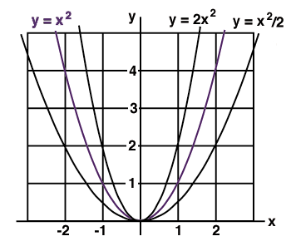
There are additional transformations called dilations and compressions, but it is a bit harder to see these changes. If you compare the graphs of 2x2, x2, and ½ x2, you'll see that the graph doesn't change its position as much as its size. The parabola for 2x2 “grows” twice as fast as x2, so its graph is tall and narrow, which is “stretching” it away from the x-axis (dilation). The parabola for the function ½ x2 “grows” only half as fast, so its graph is short and wide, which “compresses” it toward the x-axis. So, multiplying the function by a number in front changes the distance of the graph from the x-axis, by stretching it or compressing the picture.

Now compare the graphs of (2x)2, x2, and (½ x)2 The parabola for (2x)2 is “compressed” toward the y-axis, and “stretched” away from the y-axis for (½ x)2 . So, multiplying the x by a number “inside” the function (or parentheses, in this case) changes the distance of the graph from the y -axis, by stretching it or compressing the picture.

Dilations / Compressions
- a·f(x) is a vertical transformation of the graph of f(x), with a “stretch” or “dilation” if a > 1, and a “compression” if a < 1.)
- f(a·x) is a horizontal transformation of the graph of f(x), with a “stretch” or “dilation” if a < 1, and a “compression” if a > 1.

Formula for Putting it All Together

let g(x) be a transformation of some function f(x)

horizontal
transformation
↓
g(x) = a(bx – h) + k
↑ ↑ ↑
vertical horizontal vertical
transformation shift shift
& reflect over x

Practice: name the parent function, and describe the changes:

_________________________________________________________________________________________________________________________________________________________________________________________________________________________________________________________

_________________________________________________________________________________________________________________________________________________________________________________________________________________________________________________________

_________________________________________________________________________________________________________________________________________________________________________________________________________________________________________________________

_________________________________________________________________________________________________________________________________________________________________________________________________________________________________________________________

