Algebra II : 1.6,1.7,1.9 Worksheet Name_________________________

1) Let f(x) = 5x - 6 . Find each of the following.

A) f ( - 1 ) = ___________ C) f ( ) = _______________

B) f ( 0 ) = ____________ D) f ( x - h ) = _____________

2) Let g(x) = 9x - 2 . Find each of the following.

A) g ( - 5 ) = ___________ C) g ( ) = _______________

B) g ( 0 ) = ____________ D) g ( x + h ) = _____________

Graph the functions below on the graph provided. Label at least 3 points on each graph. Place an arrow on the end of any graph that continues on off the graph and a solid dot on the end of any graph that stops at a point or an open circle on any point that the graph goes up to but does not include.
3) (A) f(x) = for (B) g(x) = for
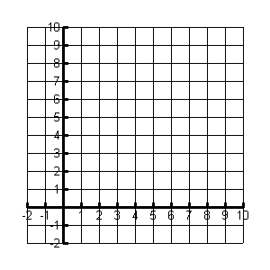
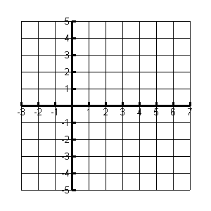

4) (A) f(x) = for (B) g(x) = - 3 for

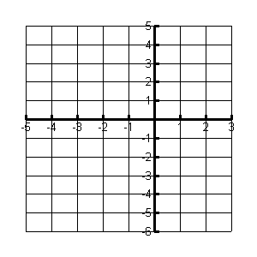

5) Draw a Linear Function 6) Draw a Cubic Function

7) Draw a Square Root Function 8) Draw a Quadratic Function

9) In your own words explain the relationship between the input and the output of a function.

________________________________________________________________________________________________________________________________________________________________________________________________________________________________________________________________

10. Is this a function? Explain your answer (5,2)( 3,9) (2,7)(0,0)(3,6)

________________________________________________________________________________________________________________________________________________________________________________________________________________________________________________________________

