Section 5.7 Worksheet #1 Algebra 2 Name _____________________
Quadratic Inequalities Period _____

#1-3 Determine whether the ordered pair is a solution of the inequality. Show your work then answer yes or no.

1. , 2. , 3. ,

#4-9 Match the inequality with its graph.

_____ 4. _____ 5. _____ 6.

_____ 7. _____ 8. _____ 9.

Use A-F to match with quadratic inequalities #4-9.
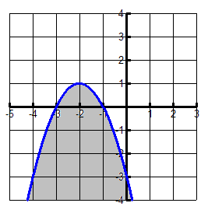
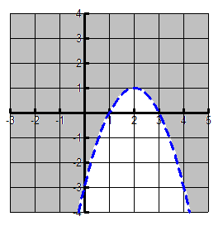
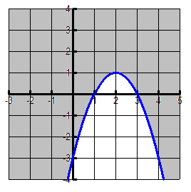
A. B. C.

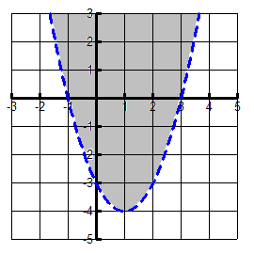
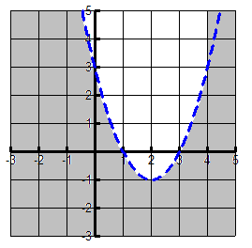
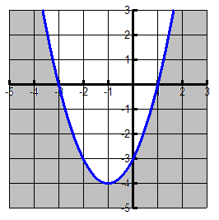
D. E. F.

#10-12 Solve each quadratic inequality algebraically, then graph the solution on a number line.

10. 11. 12.

#13-15 Graph each quadratic inequality.

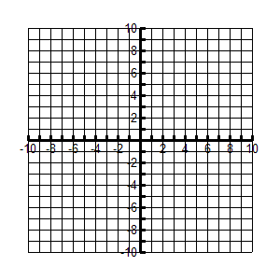
13. 14. 15.

