Section 5.7 Worksheet #2 Algebra 2 Name _________________________
Quadratic Inequalities Period ______

Solve each quadratic inequality algebraically, then graph the solution on a number line.

1. 2. 3.

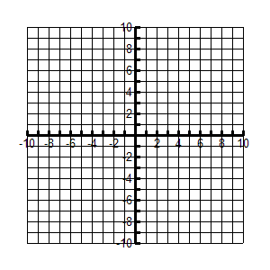
Graph each quadratic inequality, using a solid or dashed boundary line and shading the half-plane of the inequality.

4.

Vertex ____________

x-intercepts _______ _______

y-intercept _______

5.

Vertex ____________

x-intercepts _______ _______

y-intercept _______

6.

Vertex ____________

x-intercepts _______ _______

y-intercept _______

