Algebra 2 Name__________________________Period______
Quiz 1.6-2.5 Omit 1.8

- Is this a function? Circle Yes or No. Then explain. (2,4)(4,5)(7,4)(3,3)(8,1)(0,0)
___________________________________________________________________
___________________________________________________________________
___________________________________________________________________

- Simplify the expression. 4(x + 2) –x(y - 8) _________________________

- Graph a Quadratic Function

- Graph a Square root Function.

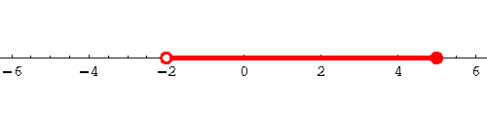

- Using the number line, write the answer in Roster Notation _____________________

- Using the number line, write the answer in Interval Notation _____________________

- Solve the equation and check your work. 14(x + 2) =98

8. Solve the inequality. 9x + 6 < 3x + 18

9. The school newspaper took a survey. Of the students polled, 15% said they did not have too much homework. Sixty students were polled for the survey. How many students said they did not have too much homework?

10. Write the inverse of -34 11.

12. Simplify 13. Simplify

14. Simplify 15. Simplify

16. Graph the line that goes through the point (1,-3) and has a slope of .
17. Write the equation from number 16 in slope-intercept form.

_____________________________

18.Write an equation for the line passing through with a slope of .

- Solve / graph the following inequality :

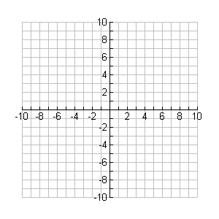

- Dan works as a house painter. He knows that it is safe to place the base of his 10-foot ladder
3 feet from the base of a house. Today he has to use a 25-foot ladder. Dan wants to keep the
same ratios in order to be safe. How far should Dan place the base of his 25-foot ladder from
the base of the house?

