# Worksheet WS 2-3 to 2-5 Algebra 2 Name___________________

Period______

Find the intercepts of each line.

1. 5x + 6y = 30 2. 2x-3y = 24

Write in slope-intercept form

3. 3y = 15-6x 4. 2x-5y = -6

Is the line Vertical or Horizontal?

5. X = 21 6. Y = -2

7. Determine whether the data set represents a linear function. If the data is linear, state the slope of the line containing the points.

A. B.

|  |  |  |  |  |
| --- | --- | --- | --- | --- |
| x | -2 | -1 | 0 | 1 |
| f(x) | 10 | 7 | 4 | 1 |

|  |  |  |  |  |
| --- | --- | --- | --- | --- |
| x | -2 | 1 | 4 | 7 |
| f(x) | -10 | -6 | 4 | 13 |

8. Graph the line with slope  and passing through the point .

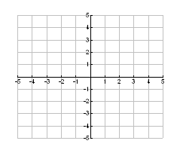

Then write the equation of the line in slope-intercept form.

# Slope-intercept form ________________________

9. Find the x-intercept and the y-intercept of the line and graph the line.

 x-intercept _______ y-intercept _______

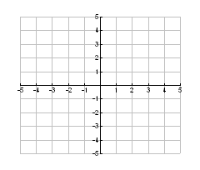

Then write  in slope-intercept form.

Slope-intercept form ________________________

1. Find the slope of the line through (-4, 12) and (-3, 8).

**Problems 13-18**, write the equation of:

13. Write an equation of a line with slope 5 and x-intercept  in **slope-intercept form**.

14. Write an equation of a line with slope  and passing through  **in point-slope form**.

15. Write an equation of a line in **slope-intercept form**.

|  |  |  |  |  |
| --- | --- | --- | --- | --- |
| X | -2 | 0 | 5 | 6 |
| f(x) | 14 | 15 | 17.5 | 18 |

16. Write an equation of a line in **slope-intercept form**.

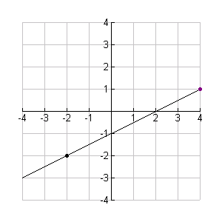

1. a line parallel to y = 3x + 5 and through  in **point-slope form**.
2. Write an equation of a line perpendicular to  and through  in **point-slope form**.

19. Graph 

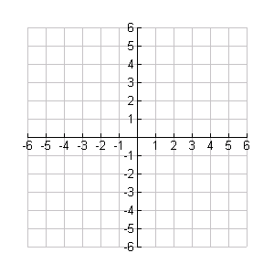

20. Graph y = 2x + 1



21. Graph a perpendicular line to y= -3/4x + 2 and through (6,-4)

