Algebra Date ____ Hour ____ Name ______________________

Angry Birds Activity

Angry Birds made fun!

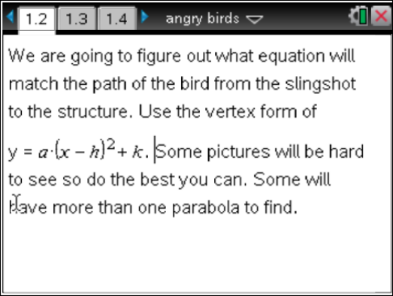 | 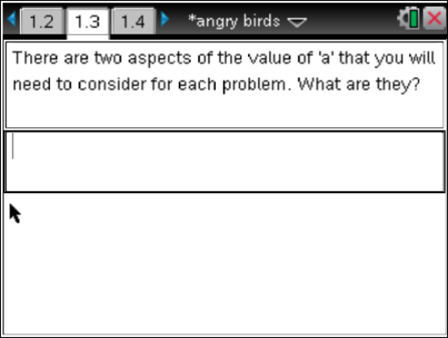
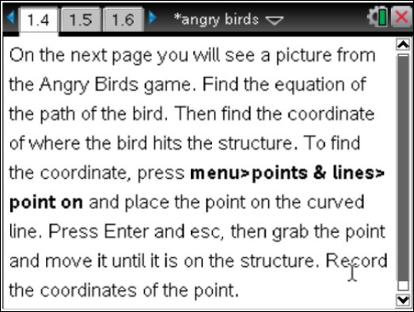 | 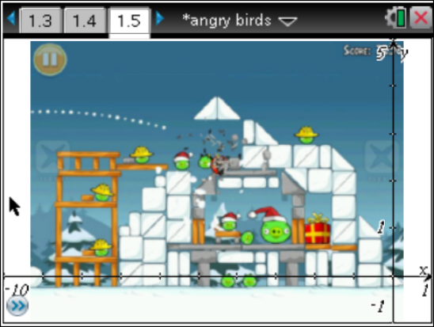  Equation _____________________________  Coordinate 1 ( ____, _____ )
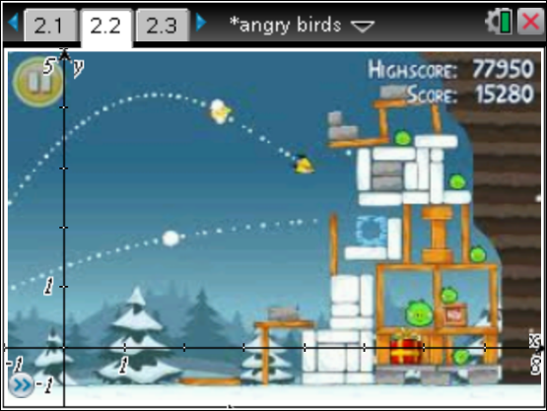  Equation 1 _____________________________  Equation 2 ______________________________  Coordinate 1 ( ____, _____ )  Coordinate 2 ( ____, _____ ) | 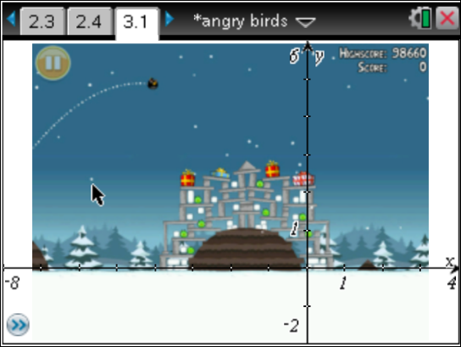  Equation _____________________________  Coordinate 1 ( ____, _____ )
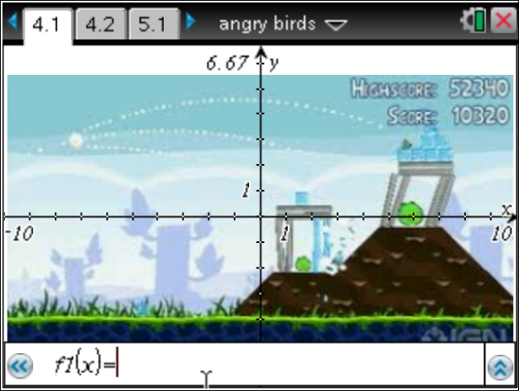  Equation 1 _____________________________  Equation 2 ______________________________  Equation 3 ______________________________  Coordinate 1 ( ______, _____ )  Coordinate 2 ( ______, _____ )  Coordinate 3 ( ______, _____ ) | 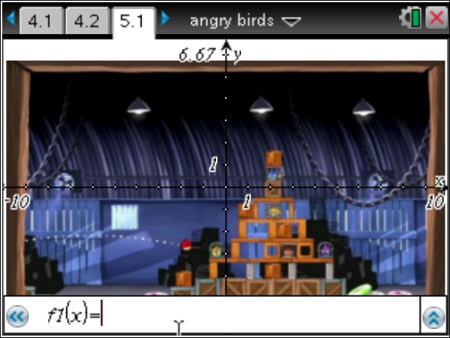  Equation 1 _____________________________  Equation 2 ______________________________  Coordinate 1 ( ____, _____ )
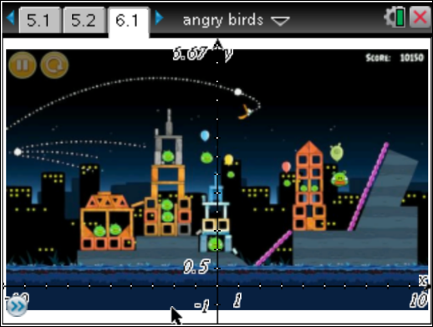 | Equation 1 _____________________________  Equation 2 ______________________________  Equation 3 ______________________________  Equation 4 ______________________________  Coordinate 1 ( ______, _____ )  Coordinate 2 ( ______, _____ )  Coordinate 3 ( ______, _____ )  Coordinate 4 ( ______, _____ )
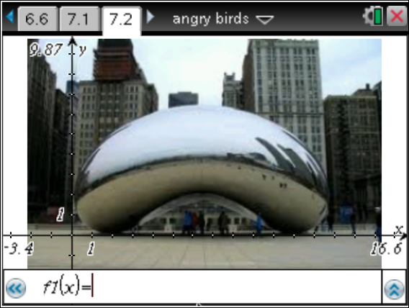

Equation ________________________________

