+

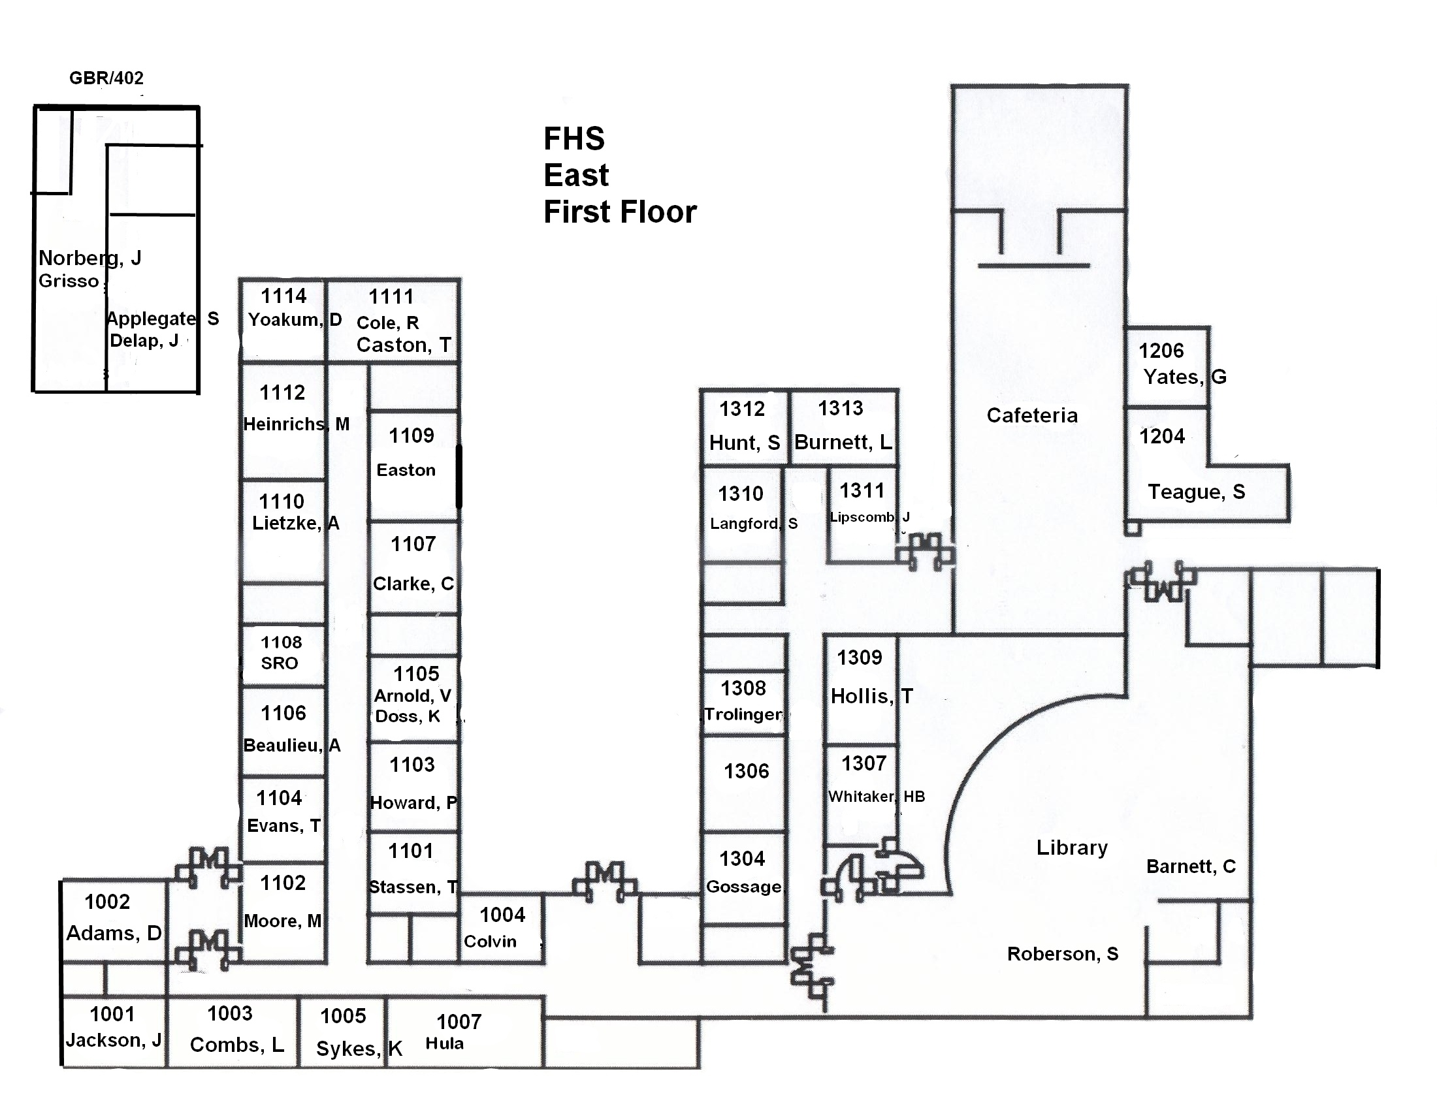
Floating Teachers
Gallagher- 1st 1312, 2nd 1310, 3rd 1313
Early- 1st 1107, 2nd 1307, 3rd 3201
Doss- 4th 1110, 5-7th 1105
Bell- 1st & 4th 3202, 2nd 3101, 7th 3201
Koenig- 1st & 2nd 3104
Rimmer- 2nd 3013, 3rd 3006

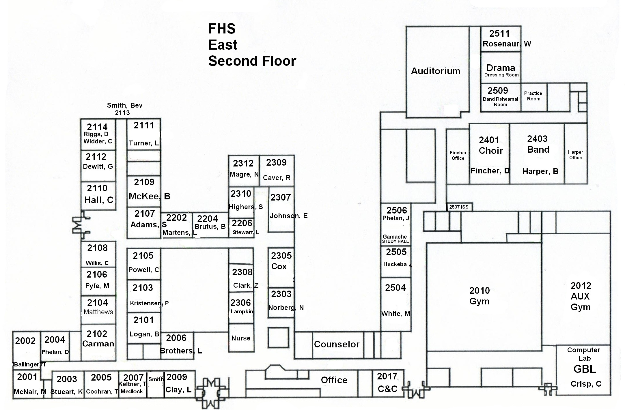
Stone Street


