Apache 1.3 on Mac OS X

Adam Norwood
Per. 3
5-20-02

So, you want to publish a website, and host it on one of your computers.

What choices do you have?

- Configure a Webserver using storebought software on a PC
- Use Mac OS 9’s clunky, built-in Web-Sharing along with a bought copy of Webstar Suite V
- Click one button in Mac OS X and have the “tried-and-true”, world’s best (and free) Apache webserver compile and run within 10 seconds.

I like choice #3, personally.

Mac OS X has the most simple server setup ever seen. There’s no software to install, no user-run compiling, just point and click one simple button—adding professional level plugins and modules just as easily once your site is off the ground.

The Simple 3 Step Apache Method

1.Once you have your site made, open the root folder of your drive, double-click Users, then your account name in the window that appears, then open up the “Sites” folder. Drag and Drop your files into the folder. Close them if you wish.

2. Open System Preferences from the Dock, then hit “Sharing”.

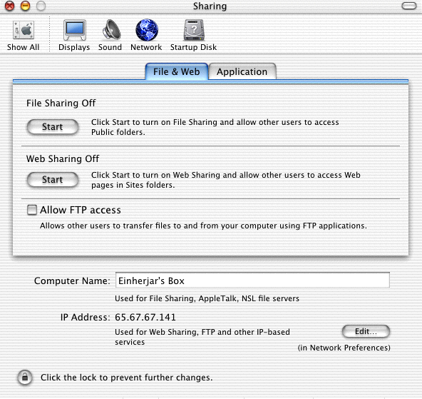

- Click the “Start” Button under ‘Web Sharing Off’, in the middle of the window. You’re done!

The More Advanced Setup

So you have your server running, but how do you make your site have an easy to remember name? People don’t want to remember IP addresses!

The answer is simple.

Get a domain name. DHS.org and DYNDNS.org offer free domain names that you can link to your IP (such as mine, http://einherjar.shacknet.nu/). Once your free account is made with either of these services, obtain a client such as DNSUpdate, available at DNSUpdate.org. What this client does is tell the servers at DYNDNS and DHS what your IP is every 12 minutes or so. Telling them this enables your IP to still be binded to the name address given to you (important if you have a “changing” dynamic IP, seen on DSL and Dial-Up services).

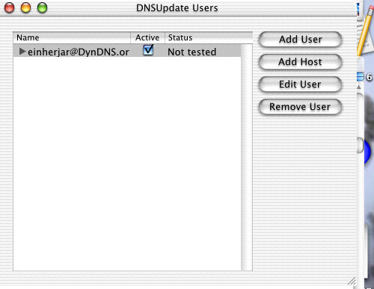

What about Administration?

With Apache and Mac OS X, administration is a snap. To update or add items, just go into your webpage builder of choice and update as you wish, then save. Apache is a smart server that updates, checks for updates, and implements changes at the point of filewrite (rather, your updating/saving of the file).

What about remote administration?

The simplest method is through, again, the Sharing control panel. 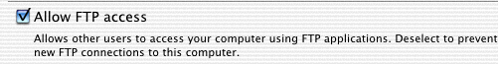

Simply check the box underneath “Web Sharing”.

Now, in your favorite browser or FTP client, you can remotely login (with your Mac OS X account and password) and access your Sites folder. (In IE or Netscape, type ftp://accountname@nameaddress_or_ip. Here’s a shot of me accessing my sites folder using Internet Explorer 5:

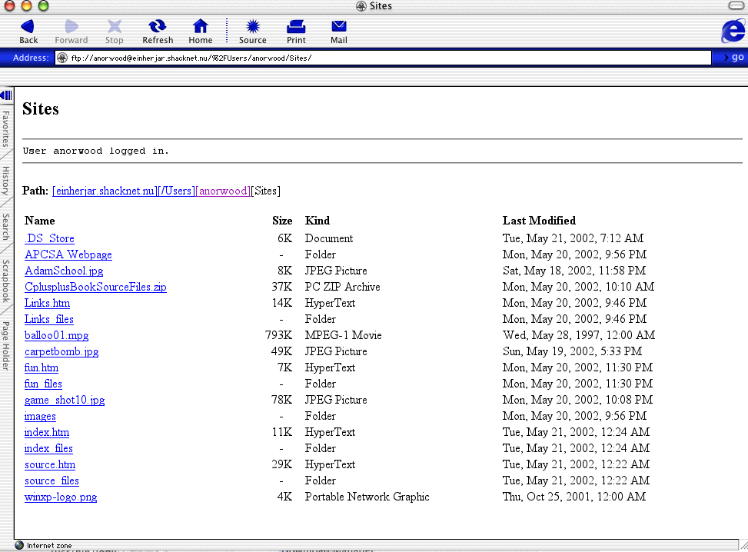

Just navigate the filesystem (OS X’s FTP setup is quite intelligent; it will automatically place you in your user folder instead of root), and open up your sites folder. Here you can delete or drag and drop new files to your server, and once the transfer is complete, Apache will update and reconfigure the server to note the change!

Additionally there’s also a more advanced method, recommended for only the most Terminal-Savvy.

With Mac OS X, you can securely access your files from a remote location using a setup called secure shell, abbreviated ‘ssh’. Using 128-bit RSA encryption, the method of SSH is highly secure, doing multiple checking of every packet as well as the travel time—substantially more secure than the typical Telnet connection. For security purposes, Mac OS X does not support regular telnet out of the box; just ssh. The syntax is as follows:

Localhost: ssh <nameaddress or ip here>

At this point, the server will reply and request the admin password. Here is a screenshot of me logging in remotely to my machine:

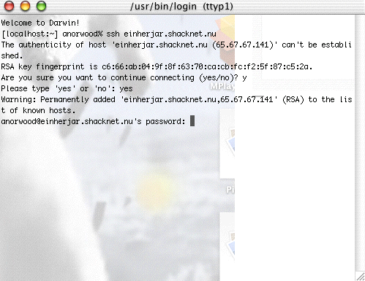
No, remember, this is UNIX…you can’t see my password. =P

From there, access change list files:

Localhost: ls

Then, use the cd parameter to change the current directory to ‘Sites’. Since you are already in your own User directory, just type this to access ‘Sites’:

Localhost: cd Sites

Now that you are in your ‘Sites’ folder, you can copy, delete, and rename files from the terminal very easily.

Let’s say you have a file on your computer that you wish to remotely send to your server. Use the copy command:

Localhost: cp oldfile’sfilepath serverside’sfilepath
(path on your machine) (path on the server you wish move your file to, in this case your username/Sites)

To delete files:

Localhost: rm filename
(NOTE: The file must be in the current directory you’re looking at, otherwise you must give a path)

To rename files:

Localhost: mv oldfilepathandname newfilename

And there you have it! A powerful webserver at your fingertips, complete with appropriate built-in html documentation and manfiles. Apple clearly has made it easy for anyone to easily create and host their own personal website!

Push-button Apache, along with setting up my DYNDNS account and nameserver, took me no longer than 20 minutes to have everything up and running as you see it. Even still, Apache is easy to configure as well on a true Unix machine. Just download the tarballs from http://www.apache.org, run the compile and startup scripts, and off you go!

Rock on, Open Source Apache programmers!

