For this examination, you may use your book, notes, the Internets and other resources but you may not use other individuals. Be sure to answer each question fully and completely using nouns, verbs and –ly words to document your path to solution. Include your Name, Date, Period, and Assignment Name.

1. Calculate the Sally’s grade for her e-Portfolio and give a scenario that would give her a B in APCSA for the 1st Quarter with the least amount of work on her part since she is a Low Rider.
 | MidTerm  1st Quarter | 1st  Quarter
Overarching Process | 3
7 Systemic Parts of APCSA | 4
Your Ability to Test | 2
Science Fair | 1
Growth | 3
Free Choice | 2
Journal | 4

2. Given this system
state the following:
• Entities

• Attributes of those entities
• Actions
• Interactions
• Information
• Relationships

3. Where can I find the API for ObjectDraw? What is it?
4. Why do we “import”? Give an example.
5. In the following line of code, explain the parameters and make a sketch of the figure:
elevator = new FilledRect(55,22,2,300,canvas)

6. What is the difference in these two lines of code and the implications of that difference?
public class elevator7 extends WindowController{
public class Elevator7 extends WindowController{

7. What is the onMouseClick method? How is different from the onMouseDrag method?

8. Why could scribble 2 use color?

9. How does “FilledArc” work?

10. What is OOP? Give a reason for it.

11. How do I set the color of a shape? What colors are allowed?

12. What percent would get you a 4 on the APCSA 2007 examination? How do you know?
13. How do you change the file associations in Windows?
14. Write the code to produce the following scene:
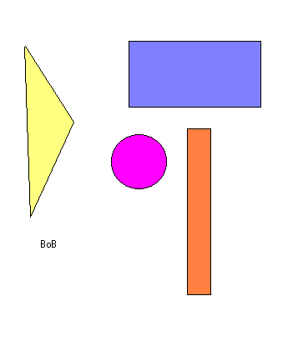

15. How would you start the Game of Life so that after at least one generation you get this?


