Learning how fish interact with the environment

What do Fish objects do?

The interaction between the fish and the environment seems somewhat complicated. We have seen that the Simulation object calls the Move function for each fish, passing it the environment as an argument. Each fish is keeping track of its position in the environment, and the environment is keeping track of fish positions as well. Thus Move must be communicating the fish move to the environment somehow. For a 1-by-N or N-by-1 environment, this interaction is replacing what was a simple call to Swim of Part 1 of this case study. It’s time to explore the Fish member functions to find out more about how fish movement is managed.

We start with the fish.h file. A fish is a simple creature; it has an identification number, a position, and an “am I defined” variable. Public member functions include the Move function, two constructors, two functions — Id and Location — that apparently allow access to the data members, an IsUndefined function, and two functions — ShowMe and ToString — that presumably produce displayable representations of a fish.

Moving to the fish.cpp file, we find that most of the functions are short. The IsUndefined function, we recall, was called from the Environment AllFish function to distinguish filled grid positions from empty ones; an “undefined” fish is created by the zero-argument constructor.

How does a Fish object move?

The most complex function is Move. It’s passed an Environment object as its argument. Here is where
Neighborhood appears; Move interacts with it as well as with the environment and with Position objects.

The first thing in the Move function is the initialization of a RandGen object as described in Part 1 of this case study. Next, EmptyNeighbors gets called. It considers four neighboring adjacent positions — North, South, East, and West — and adds any of these that are empty to a Neighborhood object, which then is returned to Move. If there are available positions to move to, one is selected at random and becomes the fish’s new position. The fish then passes its “moved” self with its new position, along with its old position, to the Environment Update function to record the movement.

It appears that the EmptyNeighbors function implements the fish movement pattern. A change to allow, say, diagonal moves would almost certainly involve this function.

Two questions arise. One: do the various functions called in Move act like we think they do? We consult position.h, nbrhood.h, and environ.h to find out, and are reassured. Two: This seems like a lot of work to get a fish to move. Why is it so difficult?

Stop and consider =>
The task now is to justify the complexity of the interaction of the fish and the environment. Would you continue
to explore the code to do this? Why or why not?

At this point, we decide to step away from the code and think about how we would design the interaction between fish and environment ourselves. This should help us understand the process better, possibly point to ways of simplifying it, and reveal any subtle aspects that we’ll need to understand in order to modify the program to handle large environments.

How might one design the interaction between fish and environment?

A good way to explore an object-oriented design is to act out the roles of the objects. Pretending to be, say, a fish, can reveal what responsibilities a fish object must have and what it must do to fulfill those responsibilities. We’ll do this.
What does a fish do?

A fish moves. (Thus something must cause it to move. In the program, the Simulation object does this.) If each fish is supposed to move to a randomly chosen neighboring grid position, this process involves three actions:
1. determining what the neighboring positions are and which of them are candidates for a move;
2. choosing one of the neighboring positions;
3. updating the fish’s position.
One might organize the program to have the fish object handle all three steps itself. Generally, however, a good object-oriented design shares responsibility among the various objects rather than having one or two objects that handle everything. Also, one advantage of an object-oriented programming environment is that it allows more accurate simulation of the real world. A real fish, for example, doesn’t know its exact coordinates in the body of water in which it’s swimming.
With which objects does the fish communicate?

In this program, the environment is modeling the collection of fish, and should therefore be able to provide information about the fish’s neighbors. It should also be keeping track of which fish is in each position in the grid. For a fish to move, it interacts with the environment in three steps:
1. constructing a neighborhood object that contains possible moves using information from the
environment;
2. choosing a random move from the neighborhood;
3. updating the new position of the fish in the environment if it has moved.
This collaboration between fish and environment means that the environment must be accessible to the fish. Either it will be passed as an argument to the Move function or it will be among the fish’s private data members.
How is the fish’s position communicated to the environment?

Role playing, we see how the fish and the environment collaborate to create the neighborhood by constructing a sample dialog.
Fish (to environment) “Tell me about my neighboring empty squares.”
Environment: “Tell me where you are; then I can tell you about your neighbors.”

What might the fish answer? In the existing program, the fish essentially says:

“Here’s my position. I have it always by my side.”

There are some alternatives, however.

“I’m Charlie Tuna — surely you know where I am!”
“Here’s the position I was just told I was occupying.”
“I’m the fish you just told to move — surely you remember me!”

That is, there are several ways for the environment to learn the position of the fish that’s moving.
• The fish can store its position.
• The fish can pass the environment some other information that would allow the environment to figure out or look up the fish’s position.
• Whoever tells the fish to move can pass the fish its position so that it may in turn pass it to the environment.
• The environment tells the fish to move and keeps track of which fish it has most recently asked to move.

Each of these options has flaws. If the fish and environment are both keeping track of the fish’s position, the possibility of inconsistency arises. If the fish asks the environment to determine its position based on other identifying information (such as the fish’s ID number), then the environment must do a search through the grid for the fish. If the simulation passes the fish’s position to the fish, then the simulation object must somehow know the position (probably by asking the environment to do a search).

In the existing code, the simulation is what tells the fish to move. It doesn’t know the fish’s position. The program could be modified to have the simulation ask the environment for the position in order to pass it to the fish, or to have it tell the environment what fish is moving. At best, that’s more code; at worst, that’s a significant restructuring of the program.
It seems that the programmers’ decision to have the fish store its own position was a reasonable one. A fish’s position is part of its simulated state, even though a fish in real life might not be aware of its position.
How does a fish choose a new position?

The dialog just described between the fish and the environment might continue in the following way:
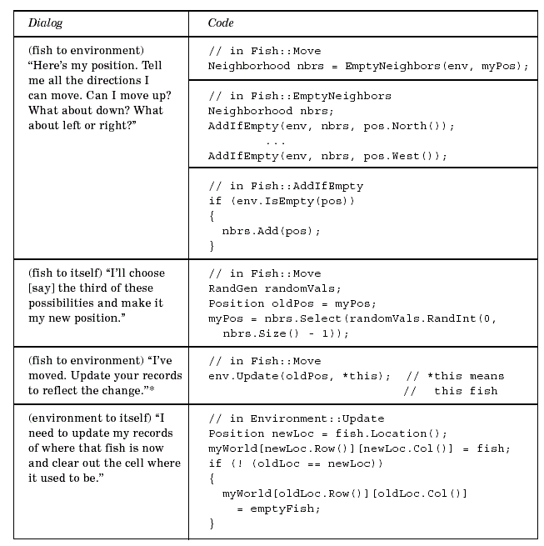
* *this is a C++ expression that’s not part of the subset in AP CS A; it refers to the fish object itself, and is
how information about the fish is transmitted to the environment.

Interestingly, the environment is relying on each fish to keep track of where it is. At least that eliminates the possibility of a fish thinking it is somewhere and the environment thinking it is somewhere else.

We now believe we understand how a fish moves.
Stop and help =>
In your own words, write a summary of the fish movement process
.
How is the Neighborhood class coded?

Two components of fish movement remain to be explored. A Neighborhood object, we find, stores positions explicitly in a four-element vector, using one of the representations previously described for a collection of objects. There are no surprises in this code (other than the fact that the size 4 is hard-coded rather than passed as an argument to the constructor). Here’s the constructor.

Neighborhood::Neighborhood()
: myList(4),
myCount(0)
{
}

A new position is stored at the end of the neighborhood.

if (myCount < myList.length())
{
myList[myCount] = pos;
myCount++;
}

The Size function keeps track of the number of neighbors. In addition, there is a Select function that retrieves a position given its index, and a ToString function, presumably for debugging, that returns a string representation of the neighborhood contents.

How is the Position class coded?

The Position class is a straightforward pairing of a row and a column. Movement directions are “hard-coded” into the class via the North, South, East, and West functions. While these functions provide good names for the various movement possibilities — one doesn’t have to remember what direction is represented by, say, 2 — they also restrict the movement possibilities. One of the requests of the biologists was the ability to test different fish movement patterns, and the current organization may be difficult to extend to complicated movement rules.

The << and == operators are overloaded to allow easy output and comparison of Position objects. However, the original programmers probably should have overloaded the != operator as well, as we discovered when we were looking at the Environment Update member function. A user of the Position class would expect to be able to use either both operators or neither one.

Exercises

Modification 1. Add the free function operator!= to the Position class. Test your modification by using the != operator to compare the two positions in the Environment Update function.

Analysis 2. In the design just discussed, the fish chooses a random number and asks for the corresponding neighborhood element. An alternative approach would have the neighborhood include a “return a random neighbor position” operation. What are the advantages and disadvantages of the approach used in the program and this alternative?

Modification 3. Make the modification described in the previous exercise and test it thoroughly.

Modification 4. Add to the Environment class an EmptyNeighbors function that, given a Position object, returns a Neighborhood object containing adjacent empty positions. Then modify the Fish Move function to call the Environment Empty-Neighbors function instead of querying the environment individually for neighbors. Thoroughly test your revised code.

Modification 5. A third alternative is to have the Neighborhood constructor query the Environment about positions adjacent to a given position. Modify the program to implement this alternative. Thoroughly test your revised code.

Analysis 6. List advantages and disadvantages of the modifications described in the previous exercises. In particular, who should be in charge of determining possible directions of fish movement, the Fish or the Environment or the Neighborhood?

Analysis 7. With a fellow programmer, act out one of the alternative designs for the communication between the fish and the environment. Keep track of all the information that the fish and environment must maintain in the alternative design. Then provide a detailed comparison with the design described in the narrative.

Reflection 8. When what seemed to be excessively complex code was encountered in the narrative, the authors resorted to trying to design the code on their own rather than continuing to explore the code. Do you do this? Why or why not? What are the advantages and disadvantages of this tactic for understanding complex code?

