Examination III

Answer each question and demonstrate the solution parts.

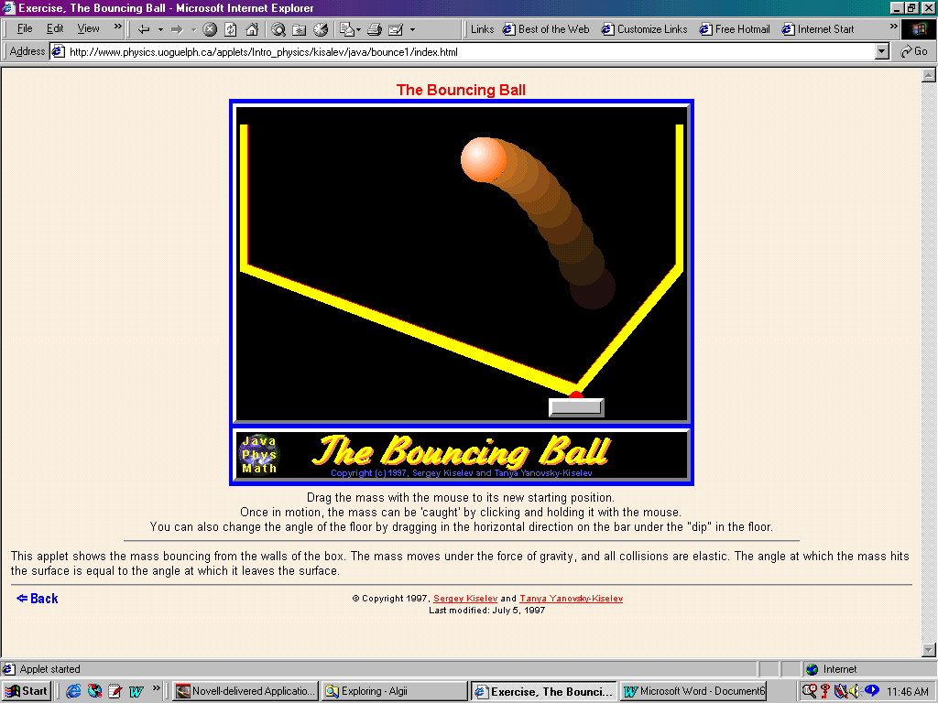
- Given the bounce below, determine the initial angle (before this bounce) and final angle (for this bounce) of the ball relative the horizon.

- Draw a time vs. distance graph for question 6, Moving in Circles, over three complete vibrations.

- Calculate the Period and Frequency if the object in question 2, takes 100 seconds to cover your graph.

- A rock is thrown from the ground into the air. At a height of 11.7 meters the velocity is observed to be 20.0 m/s at 59.5 degrees. Determine the total horizontal distance traveled by the rock, the velocity of the rock the instant before it hits the ground, and the maximum height of the rock.

- As the bunny ran, we collected the following information about its x and y position at various times. Determine the following: a) A model for the motion; b) An equation of (t,x) and (t,y); c) The velocity at 7 seconds; d) The acceleration at 7 seconds; and e) the individual displacement vectors.
Seconds | X (m) | Y (m)
0 | 87 | 3
1 | 20 | 33
2 | 12 | 37
3 | 6 | 44
4 | 6 | 49
5 | 7 | 53
6 | 9 | 56
7 | 14 | 59
8 | 19 | 59
9 | 36 | 53
10 | 34 | 48
11 | 18 | 53

- Given the following vectors, determine the indicated vector values.
a) A + B + C
b) A - A
c) 2A - 3C
- Given a 15% error, determine the range of angles (expressed in degrees) that hold for θ = sin θ = tan θ.
- Why is impetus a pseudo force? Give an example of impetus.
- For what angles would you get one-fifth of a maximum range? Explain.
- If you had 100 slugs, 100 kilograms, 100 Newtons, and 100 pounds on Earth, order them from the apparent heaviest to the lightest and identify objects in the room that are equivalent to these items.
- State your experimental design for the gedanken experiment to determine the mass of an unknown object. Include how you will exhibit the same force to each item, and how you will determine the acceleration.
- State Newton’s Third Law with a differential equation, and explain its significance.
- Two cannons are aiming at each other. One from a cliff of height h, and one on the ground a distance of k from the base of the cliff. If they both fire at the same time, sketch the path of the cannon balls, and discuss the possibility that they will collide. What information would help determine that values needed?
- A kid pulls a loaded wagon of total mass equal to 100.0 kg. She applies a constant force of 100. N along the handle at 33 degrees. Ignoring friction, compute the horizontal force on the wagon. Calculate the resulting acceleration. Determine the velocity of the wagon after a time of 10 seconds.
- Ignoring the motion of the earth around the sun and the motion of the sun through space, calculate a) the angular velocity, b) the velocity, and c) the acceleration of a body resting on the ground at the equator.

