Lab One: 47 Ways To ……

In this investigation you and your team will explore the variations in measured data. Our goal is to come to know how well we know what we know.

- Using the TI-89, CBR, stopwatch, or other device, design an experiment that will allow you to measure the time it takes for a ball to fall from a set height (approximately 2.00 meters). If you use the RANGER program your settings and results might be a follows:
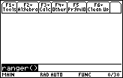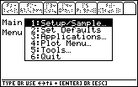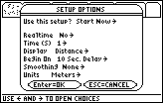

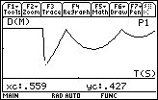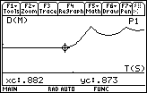
- Repeat the experiment from the same height 47 times and record the time for each drop in a list on your calculator. Record your times to the same place value (like to the nearest 0.01 seconds)
- Look at the values for the time in the list. How would you quantify the variance in these values?
- How long did it take for the ball to fall the set distance? What was the set distance?
- Calculate the Mean, Maximum, Minimum, and Standard Deviation for this set of sample data.
- Plot a Histogram of the data in your list. How does this graph support your answer to question #4?
- Do a T-Test on this data using the Theoretical value for the time (see Halliday/Resnick or Lab Two). Explain how well we know how long it takes the ball to fall the set distance.

