IP On the Move!

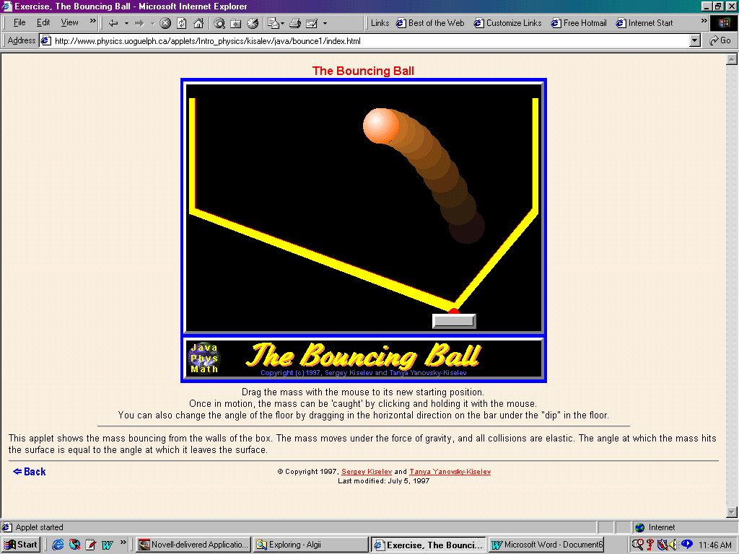
- Report any measurable values for the Racquet ball.
- Create an equation of motion for this object Before and After.
- Look at Potential and Kinetic Energy.
- Identify the velocity at 2 points.
- Make Florida with this applet, explain and document (i.e. Where is the cubic?)

