Guess:
In this method you cover the variable part of the equation and ask what needs to hold this place to make the sentence True. In:
we cover the part and look at . This means that we need ___ to be - 4. This means that . Repeating the process we need to ask what number in needed in the following sentence: . So we need a - 2 to get the - 4. So t = - 2*3 or – 6.

Solver:
Press  and move up or down () to get to the 0:Solver… option on the MATH Menu. Press  to select and if the area is not clear, press   to get a starting place.

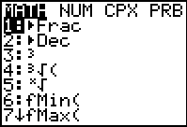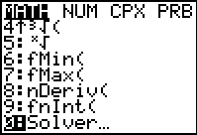

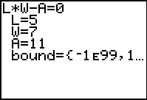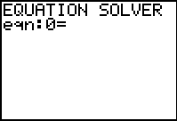

For the sentence: -27 = 12w +27 we key in

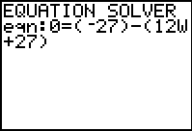

using parentheses for each side of the equation. Place a guess on the line for the variable. Then press  [SOLVE] to get the answer. Look for the bullet and don’t forget to round.

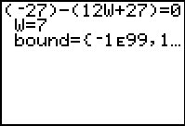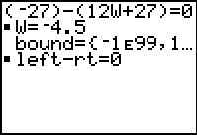

Graph Intersect:
Press □ and place the left side of the sentence on Y₁ and the right side on Y₂. Using Bubble Baby and Dolciani [] Look for the place where the two lines cross (intersect). You might have to adjust the Window to see the intersection. For this sentence 0.7(5a – 1.2) = 2a – 0.39 we replace the a with x and key in the following:
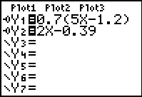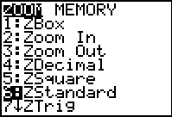

If you can  and then guess the location, do that, but if you can’t, press  [CALC] and find the actual intersection.

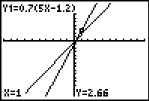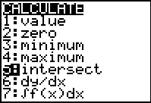

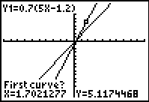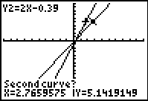

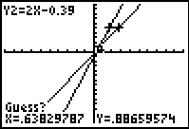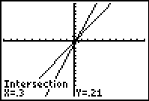

Substitution/Logic:
In this method, just place a value in for the variable and then key in the sentence using a colon to separate the two commands. Keep trying until you get the Truth (1). For 78 = 22 – 8t we have:

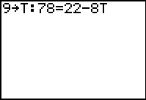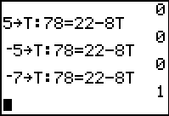

Table:
Start this method like the Intersection, but then you will set up your Table as shown below. Press  [TBLSET] and then  [TABLE] to see the Table. For the sentence 4y – 21 = 9y – 16 we have:
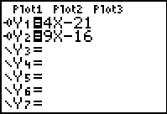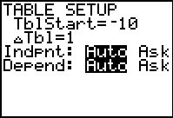

Looking for the value of x that makes the two functions equal, we have:

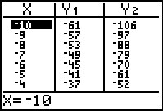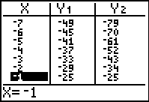

By Hand:
For the following sentence we will just do the traditional algebraic manipulation trying to get the variable isolated with a coefficient of 1.

Zero:
This starts like Solver but on the □ editor. For 8x – 12 = 15x – 4x we have:

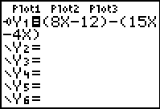

We are looking for the place where the line crosses the x-axis (where y = 0). You can trace and guess the value, or use the Zero option off of the CALCLATE Menu (Press  [CALC] ).

