Using the Algebra Plan document, identify 14 Standards from the list and for each one, find a photograph on the Internets of something REAL that relates to that Standard. Fill in the table below. Use the Glossary at the end of the Algebra Plan document if you don’t understand a concept. Remember only photographs of REAL things are allowed. Include your Name, the Date you finished the assignment, the Assignment Name and the Period - Due Friday September 12, 2008.

Standard | Photo | How does the photo represent the Standard?
Example: NLF.4.AI.5  Communicate real world problems graphically, algebraically, numerically and verbally | 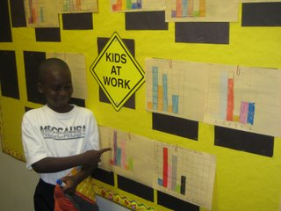 | This student is telling of real data that he collected and displayed graphically and numerically. It also looks like he is telling the photographer – so we have verbally as well. I don’t see the algebraic representation.
1.
2.
3.
4.
5.
6.
7.
8.
9.
10.
11.
12.
13.
14.

