Team: ________________ ___________________ ______________

We now wish to explore the Bouncing Ball for one last (?) time in our quest for the Quadratic within. If “we” didn’t collect the information, then we could collect information about time as well as height from the bouncing ball. Maybe that would be where we could find the Quadratic? So, here we go with one more try!
Materials
- Racquet Ball | - Tape for the wall | - CBR
- 150 Centimeter  Tape measure | - Graphing calculator with 12000 bytes free | - CBL/CBR APP
- Long CBR to TI-83/82 Cable | - Clamp for the CBR | - TI Graph Link and cable

- In your group, collect the data for a dropped ball when it is dropped from a height of just above 100 centimeters. Pick a location from which you can attach the CBR clamp so that the “eye” of the range finder is 150 cm above the floor. The goal is to use the RANGER program, using the Ball Bounce application to get data for about 5 or 6 bounces, with the times that are associated with the bouncing ball. Drop the ball so it moves straight up and down as it bounces.
- Set up the experiment and test it out with the RANGER program.
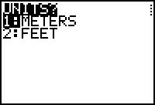
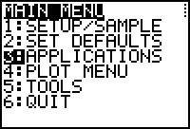
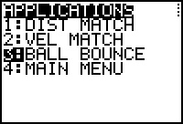
- Run the RANGER program from the CBL/CBR APP and select 3:APPLICATIONS from the MAIN MENU. Then select 1:METERS from the UNITS? Menu and 3:BALL BOUNCE from the APPLICATIONS Menu.
- Follow the instructions and drop the ball, just after your partner presses the TRIGGER on the CBR. The ball should be held under the CBR at just above 100 cm from the floor, so that the CBR will pick up the bounces from 100 cm down. If you get a graph like this, then you have your data! It will take several trials to get data like this.
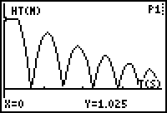
- Exit the program and send each team member the lists (L₁ and L₂). Help them set up the plot as you have on your calculator.
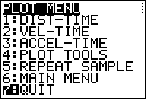 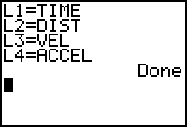
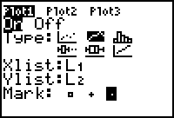 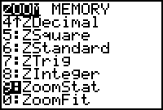
- Trace along the graph and identify the X (time in seconds) and Y (height in meters) of each peak of the graph. This represents the height of each bounce. Call the 1st good peak Bounce 1. Fill in the data in TABLE 1. Collect as many peaks as you are sure of.
Table I
Bounce  Number | Time  (seconds) | Height  (cm)
1
2
3
4
5
6
7

- Calculate the Ratios of the Heights from Table I and then report the Average Ratio.
Table II
Ratio of Bounce Heights

- Average of the Ratios: ___________________________
- Now we wish to get the name of the Quadratic that represents one bounce. Select off one bounce to see a single Quadratic. From the CATALOG MENU pick Select( and name two new list.
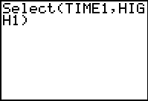
- Pick the 1st good data point for the selected bounce, and then the point that best represents the last part of the bounce.
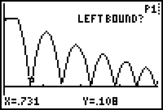
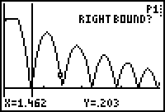
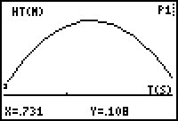
- Now we wish to get the name of the Quadratic that represents this bounce. Run the Transformation Graphing APP and go to the □ editor to place in the other vertex form of the Quadratic. Let A, B [H], and C [K] have their default values. Adjust the values of A, H, and K until you have the best fit.
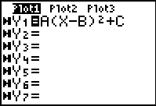
- Report this equation and the graph that supports it.
- Now produce the function that passes through the peaks of the good bounces using the data from Table I. Use the Transformation APP and report the name of the model as well as the values of the parameters and the graph that supports your selection.
- Give the name of the quadratic in the standard and the Intercept forms.
- Documentation all of your work and make a Group of the list with all bounces for the exam.

