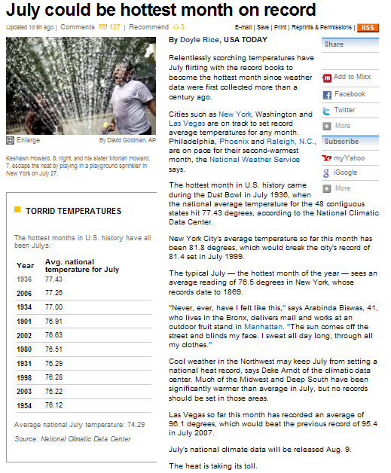
http://www.usatoday.com/weather/news/extremes/2010-07-30-1Ahotjuly30_ST_N.htm

