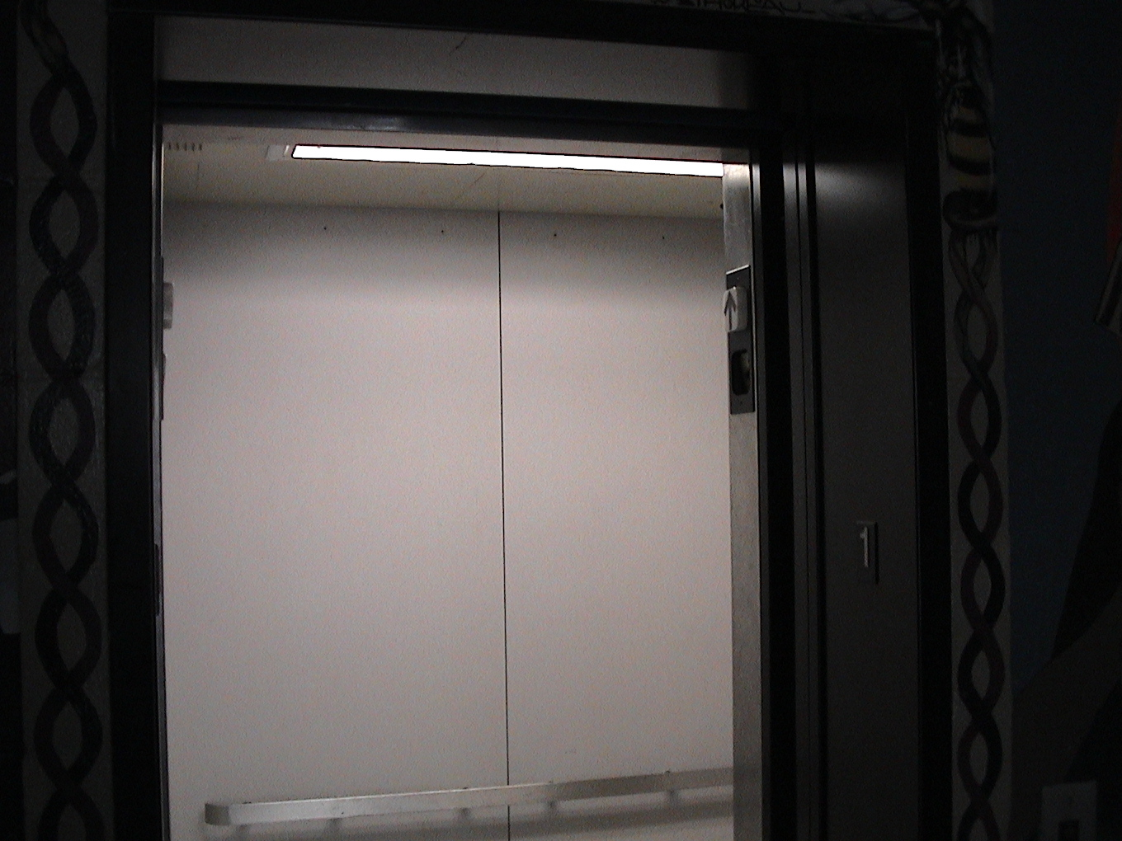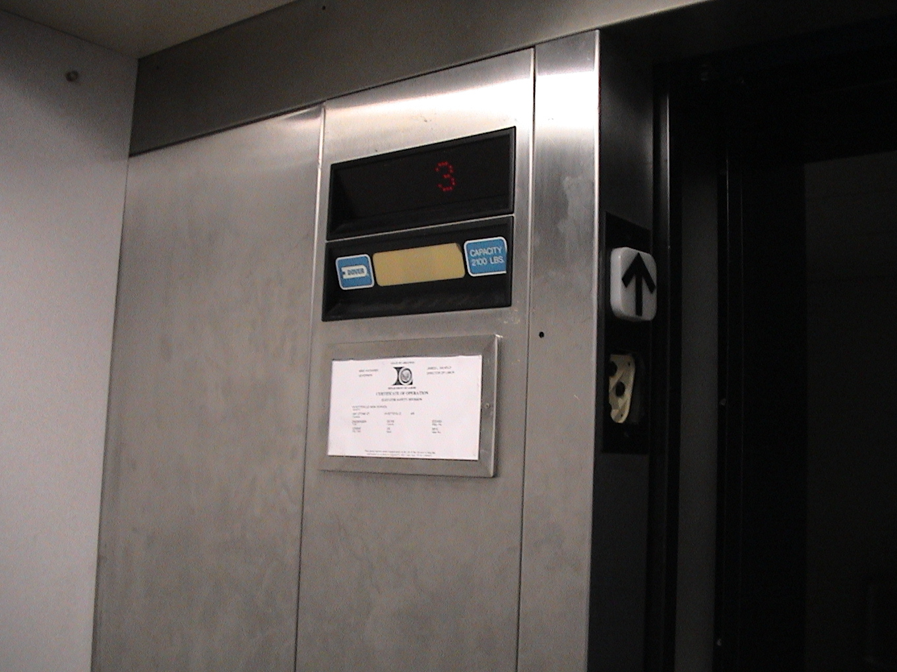
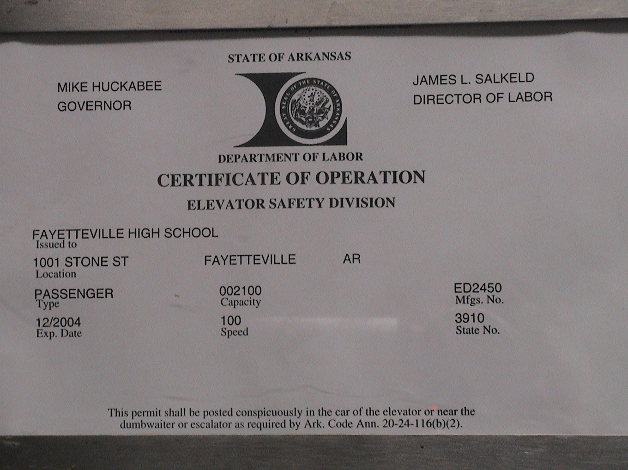
Shown above are photos of the elevator at my school. Notice that the Speed of the elevator is 100. Use the Convert tools on the calculator to determine the units of this speed and then explain why you think you have discovered the units of the speed.
- Enter 100 on your Home Screen since the speed of this elevator is 100.
- Press   (to access the CONVERT feature)
- Select 7: Speed
- Using the arrow keys scroll down to some starting unit like 3: mi/hr press .
- Using the up arrow key press  on a second unit like 2: m/s to convert to.
- Press  to see the answer
- Repeat this several times using different units until you think you know the units of the speed of the elevator.
- Write an explanation for your unit selection.

