TI-73 | TI-83 Plus | Comments
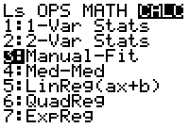 | 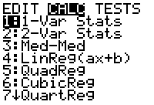 | Regressions: Just 5 on the 73 with Manual-Fit, 10 on the 83P
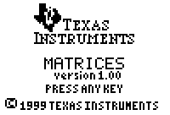 | 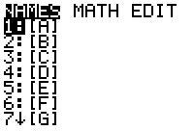 | Matrix: An application on the 73.
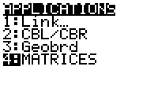 | 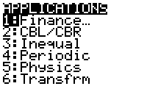 | Number of APPS: 8 on both, not 94!
   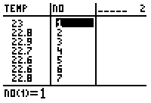  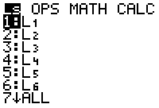 |  [LIST]  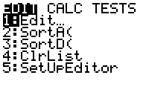  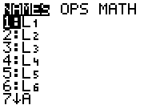 | Accessing lists and location of regressions
 |  [LINK] | Link: Access Point
25K RAM, 64K ROM | 24K RAM, 160K ROM  24K RAM, 1.5MB ROM - SE | Memory
TI-73 | TI-83 Plus | Comments
☹ | 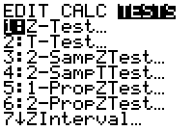  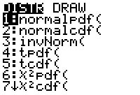 | Statistical Test
☹ | 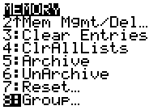 | Archiving
☹ | 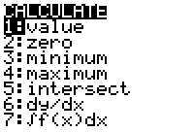 | CALC Menu
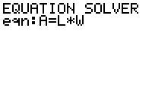 | 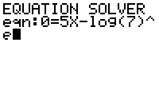 | Solver, not =0 on 73!
TI-73 | TI-83 Plus | Comments
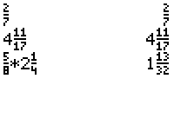 | 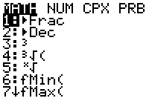 | Fractions
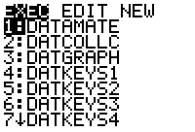 | 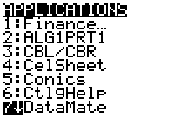 | DATAMATE: An APP on the 83P, bunch of Programs on the 73.
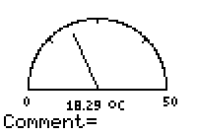 | 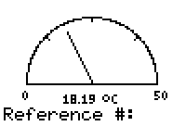 | GAUGE: Comments, Categorical vs. Numerical: TCMNT or TREF.
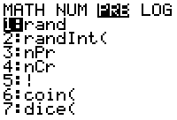 | 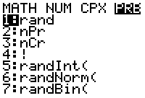 | RAND/PRB
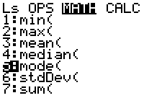 | ☹ | Mode (Measure of Central Tendency)
TI-73 | TI-83 Plus | Comments
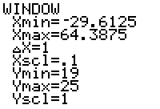 | 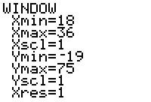 | WINDOW Delta X, and Xres missing. 83P starts at Xmin and adjust, 73 starts at median of range, and adjust.
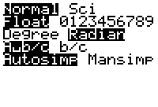 | 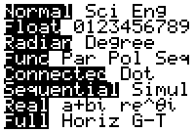 | MODE: Graph types, Split screen, Complex, Simultaneous graphs
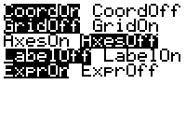 | 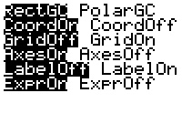 | FORMAT: Missing Polar.
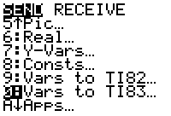 | 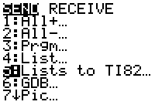 | Link: To 83…
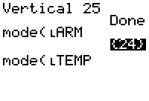 | 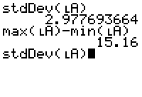 | Memory Stack Access
TI-73 | TI-83 Plus | Comments
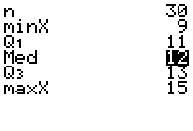 | 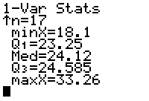 | 1-Var Stats
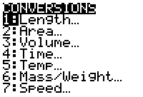 | ☹ | Convert
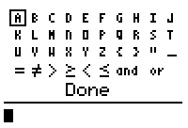 |  | TEXT and location of various symbols.
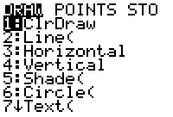 | 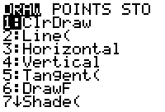 | Drawing Tools  vs.  [DRAW]
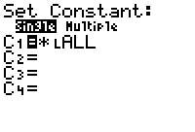 | ☹ | Constant Key
TI-73 | TI-83 Plus | Comments
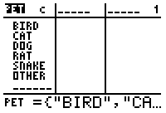 | ☹ | Categorical List
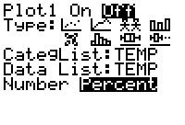 | 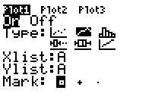 | Plot Types: 73 Missing z-Distribution,
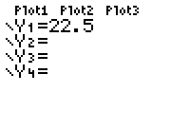 | 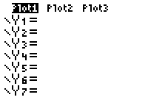 | Y=: Only 4 on the 73
☹ | 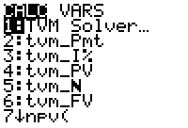 | Finance
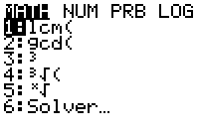 |  | 
TI-73 | TI-83 Plus | Comments
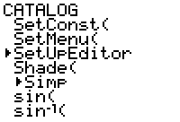 |  | SetUpEditor in CATALOG only on the 73.
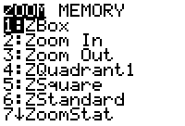 | 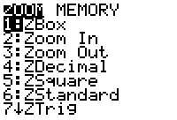 | ZOOM
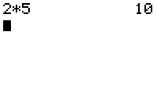 | 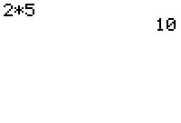 | Same line output.
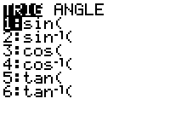 | 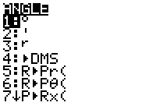 | Trig
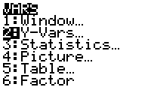 | 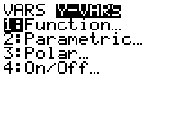 | Y-Vars
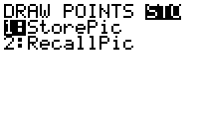 | 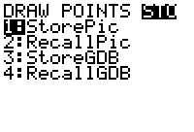 | No GDB
TI-73 | TI-83 Plus | Comments
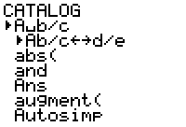 | 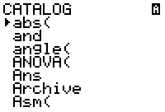 | CATALOG: access to Alpha
☹ |  | Grouping files
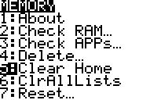 | 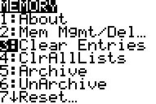 | Clearing Memory Stack  Also in the Catalog
☹ | 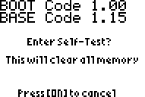 | Self-Test
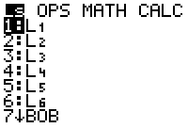 | 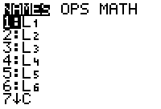 | Location of L1, etc. off the keyboard on the 73.  
TI-73 | TI-83 Plus | Comments
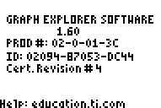 | 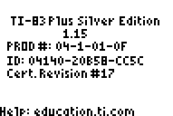 | OS
Area Formulas  Buidling Perspectives™  Geoboard  Guess My Coefficients  Logic Ladder  Math by Hand  Matrices  Number Curiosities  Number Line  Probability Simulation  Puzzle Tanks™  Rational Number Rampage  Safari Search™  SMILE Mathematics App  StudyCards™  TI CBL™ /CBR™  Topics in Algebra I (Chapters 1-4)  Topics in Algebra 1 (Chapter 5) | Advanced Finance  Area Formulas  Catalog Help  CBL™ Chem/Bio  CBL ™ Physics  CBL ™ System Experiment Workbook  CellSheet™  Chinese Help  Conic Graphing  DataMate  Decimal Defender  Fundamental Topics in Science  GeoMaster™  Guess My Coefficients  Inequality Graphing  Language Localization  Logic Ladder  Math by Hand  NoteFolio™  Number Curiosities  Organizer  Periodic Table  Polynomial Root Finder and Simultaneous Equation Solver  Probability Simulation  Rational Number Rampage  Real World Math with CBL™  Science Tools  SimCalc Mathworld Shareware  SMILE Mathematics App  Solve It!  Start Up Customization  StudyCards™  TI CBL™ /CBR™  Topics in Algebra I (Chapters 1-4)  Topics in Algebra 1 (Chapter 5)  Transformation Graphing  What is my Angle?  World Geography | APPS: Common, unique, free, and VIP
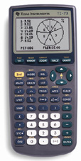  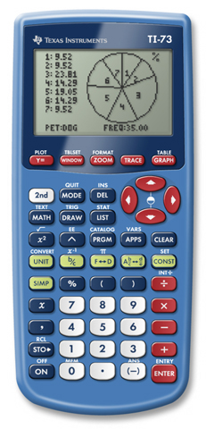 | 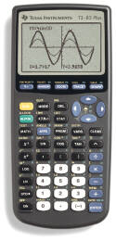  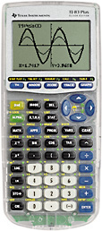 | Key locations

TI-73 PPT, Compare Chart, Manuals 73 or 83p, Bid Specs 73 or 83p and DAY’s Home and Link
For Additional Information Contact
David A. Young
dyoung7@prodigy.net
dyoung@fayar.net
day7@swbell.net

