Activity Overview
In this activity, you will create a question document using the Question application of the TI-Nspire™ family of Teacher Software. You will also explore the properties of the six question types – Multiple Choice, Open Response, Equations and Expressions, Coordinate Points & Lists, Image, and Chemistry.

Materials
- TI-Nspire™ or TI-Nspire™ CAS Teacher Software

Inserting a Question
- Open the Teacher Software.
Note: TI-Nspire™ documents with the Question application can only be created with the Teacher Software. The Question application is not available in the TI-Nspire™ Student Software.
- Go to the Documents Workspace and create a new document by clicking the New Document icon, .
- Insert a Question application by selecting Insert > Question.
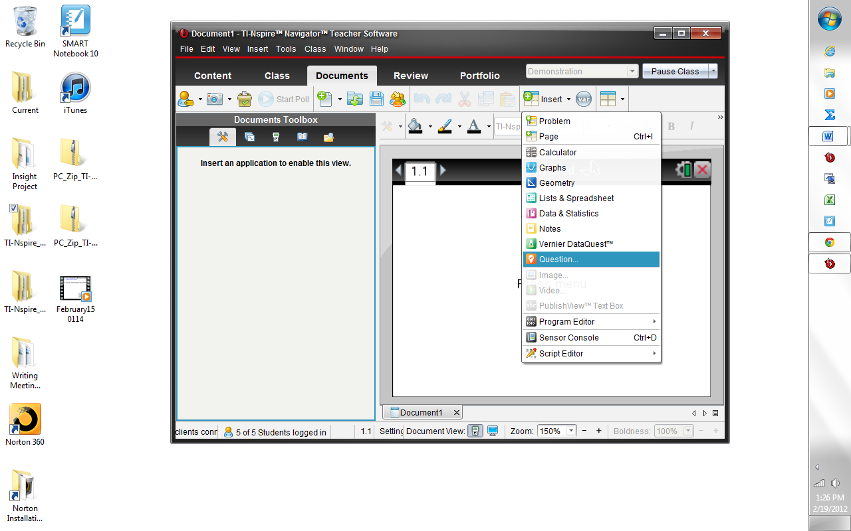
After you select Insert > Question, the Choose Question Type dialog box will appear. The following Activities will illustrate the different question types.
Activity 1: Inserting a Multiple Choice Question  - Select Custom Choice.  Note: A brief description of the highlighted Question Type appears at the bottom of the window.  - Click Insert.  - In the text box type: “Solve for x:”  - Insert an expression box by clicking on the Document Tools pane in the Documents Toolbox and selecting Insert > Expression Box.  - Type the equation into the Expression Box. Press Enter to close the Expression Box. | 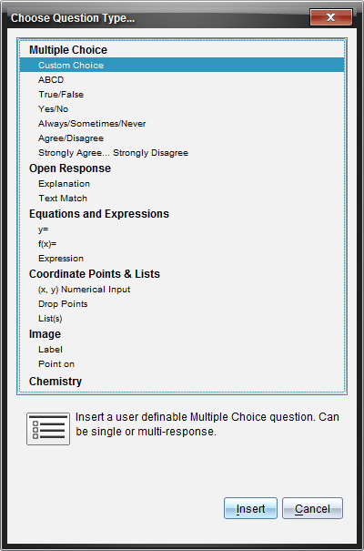
Shortcut: An Expression Box can also be inserted by pressing Ctrl+M.

Tech Tip: A variety of math templates can be accessed by selecting the Utilities pane in the Documents Toolbox.

- Enter answer choices: Click in the first answer field. Insert an Expression Box. Type the first answer choice, putting a space between the integer and the fraction. Press Enter to close the Expression Box. To move to the next answer field, click in the next field or press Enter. Continue to type the following answer choices.  , , ,  Tech Tip: To remove an empty answer field, click in that field and press the Backspace key. | 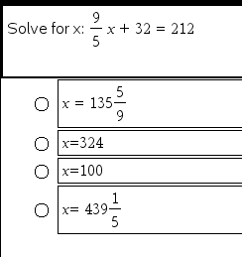
- As you type answer choices, they automatically appear in the Correct Answer fields in the Configuration panel of the Document Tools.  - Select the correct answer by clicking on the check mark in front of the answer choice.  Note: In the Configuration panel, the Multiple Choice Properties can be changed to allow a different Response Type. Single Response allows one correct answer, while Multiple Response allows multiple correct answers. The Multiple Choice Properties and Correct Answer fields can be collapsed by clicking ¤ and expanded by clicking ¢.  - Press Enter to complete the question.  There are two types of question documents: Exam and Self-Check. Exam documents can be scored using the TI-Nspire™ Navigator™ System or TI-Nspire™ Navigator™ NC System.  A Self-Check document allows students to check their answers after they select or enter a response. The default setting for the Document Type is Exam.  - To create a Self-Check Question document, select Teacher Tool Palette > Question Properties. Change the Document Type to Self-Check and click OK. | 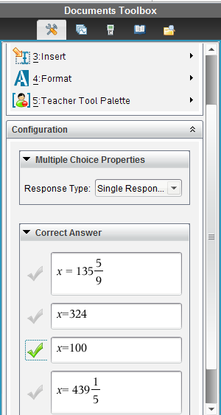
 | 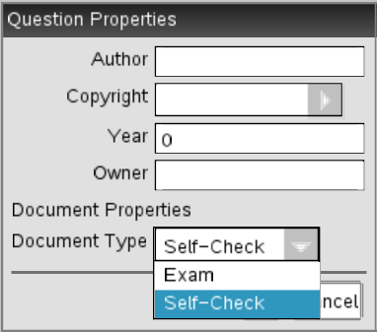
The following notes apply to Self-Check documents:
- The document type selected applies to all questions in the current document.
- After students answer a question in a Self-Check document, they can check their answers by selecting Check Answer from the Menu. A message (“Your current answer is correct.” or “Your current answer is incorrect.”) is displayed. If the answer is incorrect, two options appear: Show Correct Answer and Try Again.
- In Self-Check documents, the Explanation response type (not scored) question does not display the correct or incorrect answer message when students select Check Answer. However, any suggested response entered by the teacher will be displayed. The Text Match response type (scored) requires students to exactly match the correct answer, including templates, if applicable. When students select Check Answer, the correct or incorrect answer message will be displayed. The other types of Multiple Choice Questions are inserted in similar fashion.
Activity 2: Inserting Open Response Questions

An open response question prompts the student to write a response. An explanation question type allows students to respond without any predefined answers. A text match question type allows the teacher to specify an answer for the student response. Text match questions are automatically graded; open response questions are not automatically graded.
- Insert a new question by clicking Insert > Question  - Select Open Response > Text Match.  - Click Insert.  - Type the following question into the question field:  A triangle, all of whose angles measure less than 90° is called a/an _________ triangle.  Note: You can type any combination of text, math expressions, and chemical equations in the Question Area and Suggested Response area. You may also add an image in the question text area. | 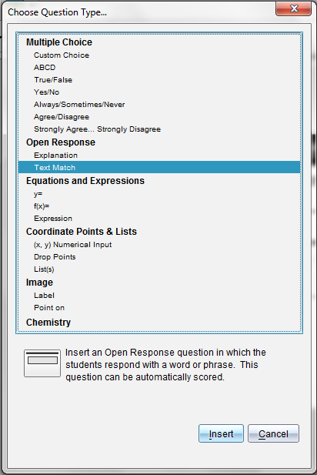
- Open the Configuration tool. Select the response type as Text Match, and type the correct answer. The Text Match response type requires students to exactly match your suggested response.  - Select the Ignore Case check box if capitalization is not important.  - Press Enter to complete the question.  Tech Tip: Math templates and symbols can also be accessed by clicking the Utilities icon in the Correct Answer field.  Note: The Explanation response type allows students to give answers that closely match your suggested response. | 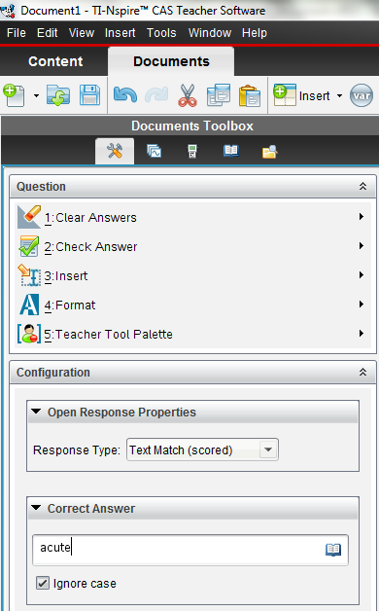
Activity 3a: Inserting Equations and Expressions Questions  - Insert a new question by selecting Insert > Question.  - Select Equations and Expressions > Expression.  - Click Insert.  - Type the following problem into the question field (use an Expression Box for the equation):  What is the slope of the line ?  - In the Configuration panel, under Expression Properties, change Response Type to Number. Type in the Correct Answer field. If desired, change the Tolerance from ±0 to ±0.001. Press Enter. |  | 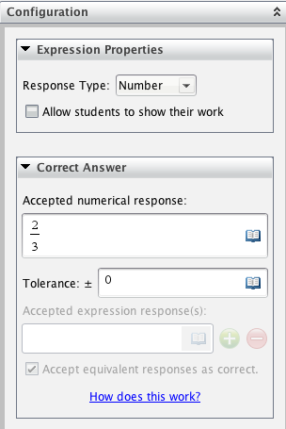

Activity 3b: Inserting Equations and Expressions y= Questions  - Insert a new question by clicking Insert > Question.  - Select Equations and Expressions > y =.  - Click Insert.  - Type the following problem into the question field:  Write the equation of a line whose slope is –2 and whose y-intercept is 3.  - In the Configuration panel, under Equation Properties, check the box for Include a Graph Preview. In the Correct Answer field, type –2x + 3 as an accepted response. Check the box for Accept equivalent responses as correct.  Note: In the Configuration panel, under Equation Properties, the Response Type options include y = and f(x) = notation. The number of responses and prompt location can be changed, and students can be allowed to show their work in a series of blank fields.  Note: When might you choose not to check the box for Accept equivalent responses as correct? | 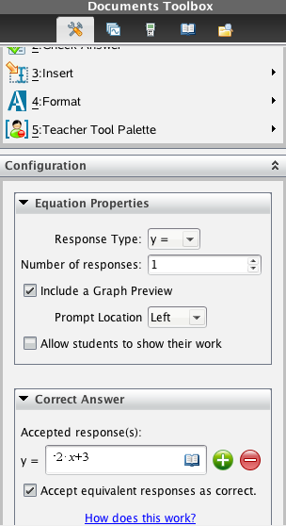
Note: By changing the Equation Properties to Include a Graph Preview, the page layout of the question is automatically changed and a Graphs application is inserted on the right side of the screen. When an expression is typed into the y = field, the function is automatically graphed. | 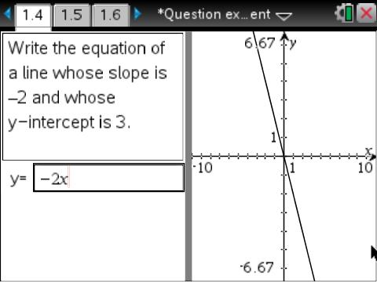
Activity 4: Inserting Coordinate Points & Lists Questions  - Insert a new question by clicking Insert > Question.  - Select Coordinate Points & Lists > Drop Points.  - Type the following problem into the question field:  Plot a point whose y-coordinate is twice its x-coordinate.  - In the Correct Answer field, enter (1, 2) as an acceptable answer. Add an additional acceptable answer field by clicking the green addition icon. Enter (2, 4) as an acceptable answer. Check the box for Accept equivalent responses as correct. | 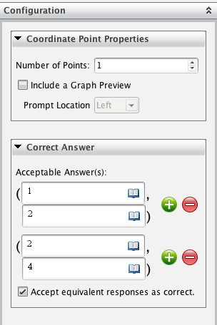
Note: The Drop Points question type automatically includes a Graphs application with a grid | 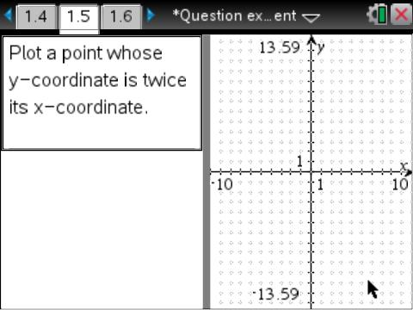
Activity 5a: Inserting Image Question (Screen Capture)  - Insert a Graphs page by clicking Insert and selecting Graphs. Graph the function f1(x) = x² + 2x – 3.  - Press and choose Capture Page to capture an image of the graph. The image is automatically copied to the clipboard.  Tech Tip: A keyboard shortcut for Capture Screen is Ctrl+J. | 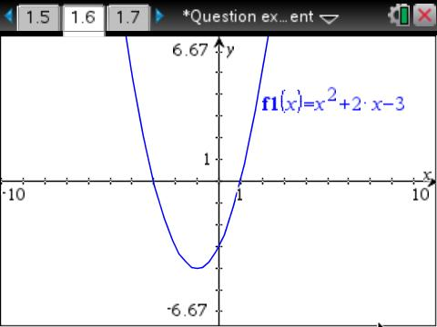
- Insert a new question by clicking Insert > Question.
- Select Image > Point on.
- Click Insert.
- Type the following problem into the question field:
Identify the zeros of the quadratic graphed below.
- Click on the bottom half of the screen and choose Edit > Paste from the drop-down menu at the top of the screen.
- In the Configuration menu change the number of responses to four. This will place four points on the image. Move the points so that two of the points are on the two x-intercepts, one is on the y-intercept, and the final point is on the vertex.
- In the Answers menu, click the check boxes to identify the correct answer(s).
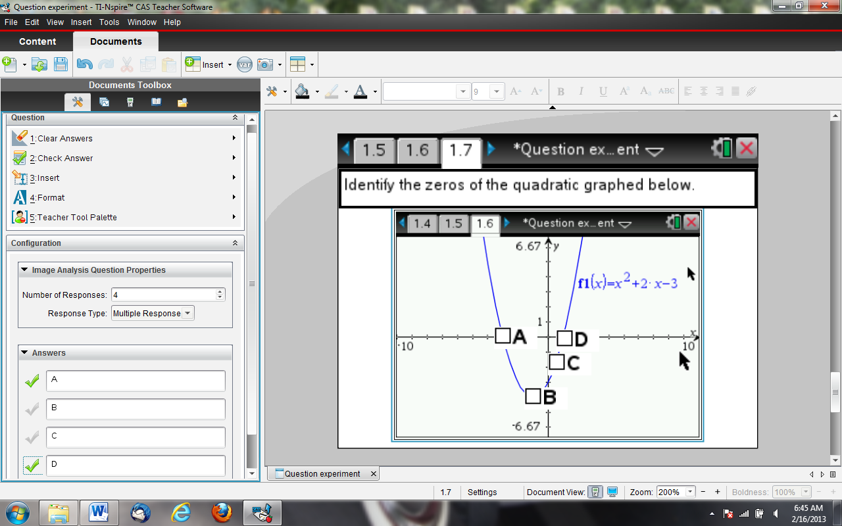
Note: Delete the extra Graphs page by changing to the Page Sorter View in the Documents Toolbox, right-clicking on the extra page, and selecting Delete.

Activity 5b: Inserting Image Question
- Insert a new question by clicking Insert > Question.
- Select Equations and Expressions > y =.
- Go to the Configuration panel in the Equation Properties panel. Select Include a Graph Preview and change the Prompt Location to Top.  Note: To maximize the area of the Graph Preview, grab and move the gray bar separating the question and answer fields from the Graph Preview. | 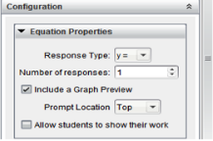
- Insert an image into the Graph Preview by clicking the graph and then selecting Insert > Image. Choose Bridge1.jpg and click Open.  - Press ctrl + G to close the entry line.  - Type the following problem into the question field:  Write an equation to model the suspension cables. | 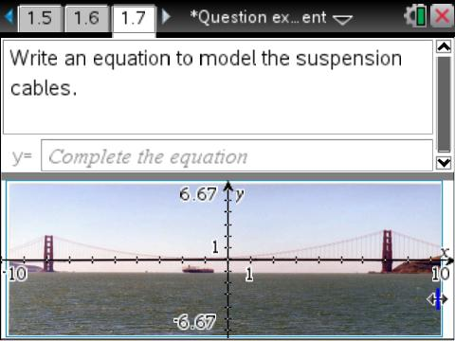

Activity 6: Inserting Chemistry Questions
- Insert a new question by clicking Insert > Question.
- Select Chemistry. Type the following problem into the question field:
What is the chemical formula for water?
- In the Correct Answer field type H20. The Chem Box will automatically convert the “2” to a subscript. Chem Boxes can be used on Question and Notes pages to support chemical formulas.
- Save the document.
Note: Chemical symbols are automatically recognized. Subscripts are created automatically when numbers are typed after chemical symbols. Exponents are created by using l. The equivalence arrow is created by pressing =.

