



Introductions
- Brief Overview of Nspire and TEKS addressed
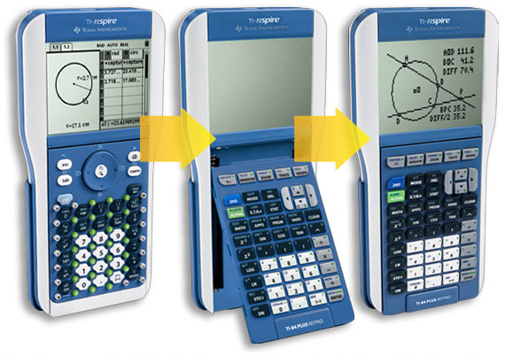
- Lab Activity: TI-nspire — Circular and Simple Harmonic Motion—ID: 12227
- TI-nspire Activity: Light & Waves—ID:9462
- TI-nspire Activity: Bending of Light—ID: 8878
11:30-12:30—Lunch
- Lab Activity: TI-nspire—A Little Light Work—ID: 8547
- Lab Activity: TI-nspire—Polarizing Light—ID: 9599/13706
- TI-nspire Activity: Converging Lenses-- ID:13697
- TI-nspire Activity: Plane Mirrors-- ID:8737
Reflections/ Closure

