How to make a Climograph on Excel

- Type in your information as shown, highlight the data, and click chart wizard on the tool bar.
Click the “Custom Types” tab, scroll down, and click "Line-Column on 2 Axes". Click next.
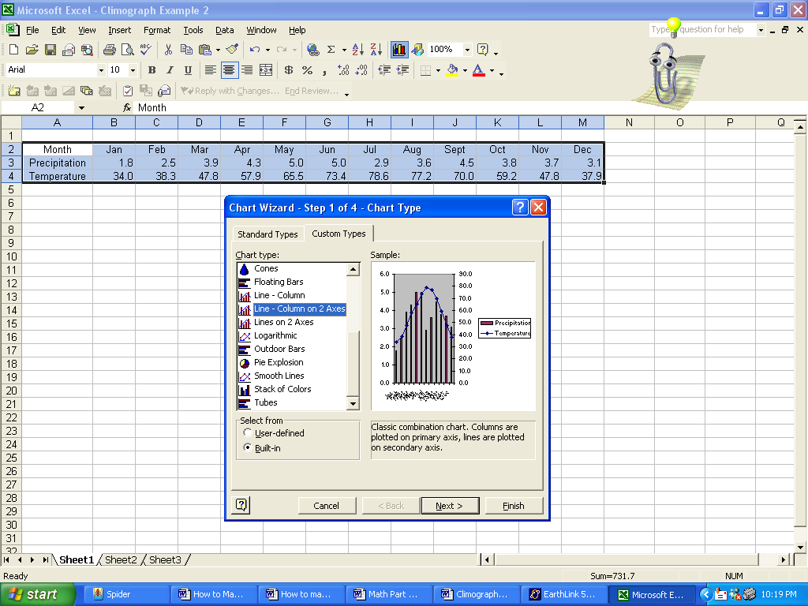

2. Make sure your graph has a line graph and a bar graph. Click next.
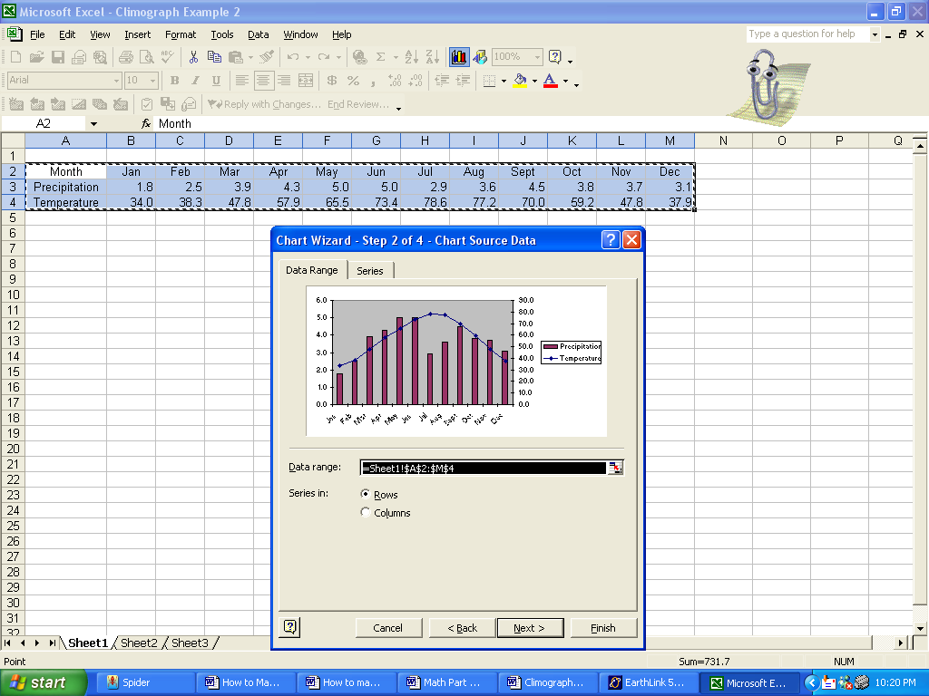

3. Fill in the title “Climograph for “your city”. Fill in the Category (X) axis: Months of the Year
Fill in the Category (Y) axis: Precipitation in Inches. Skip second category (X) axis.
Fill in the Second Value (Y) axis: Temperature in Fahrenheit. Do NOT click next yet.
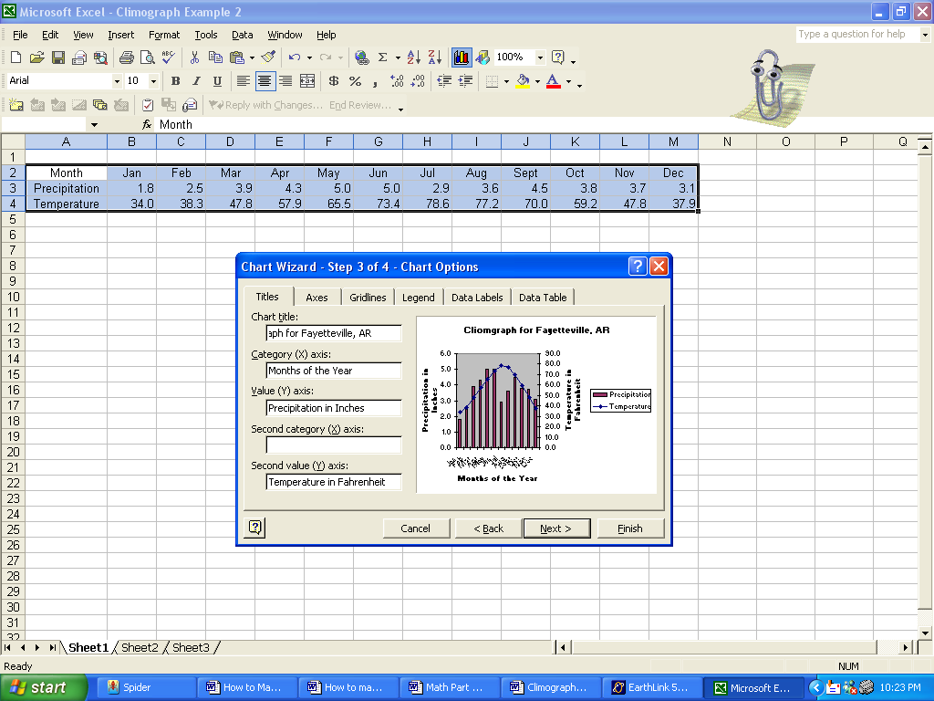

4. Click on the "Gridlines" tab and choose Major gridlines for the Value (Y) axis. Do NOT click next.
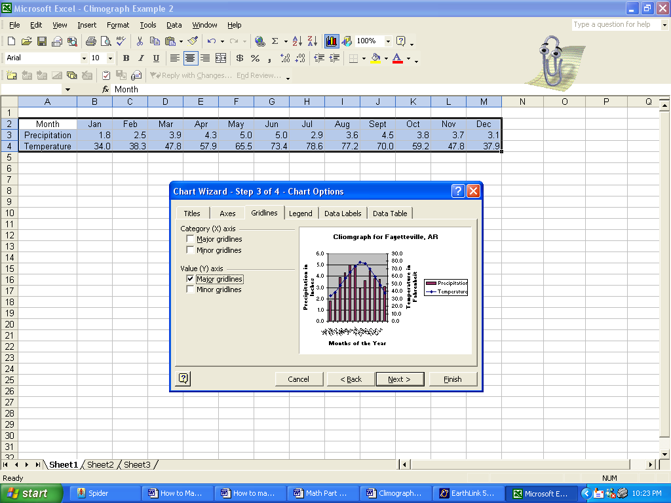

5. Click on the "Legends" tab and choose “Bottom”. Click finish.
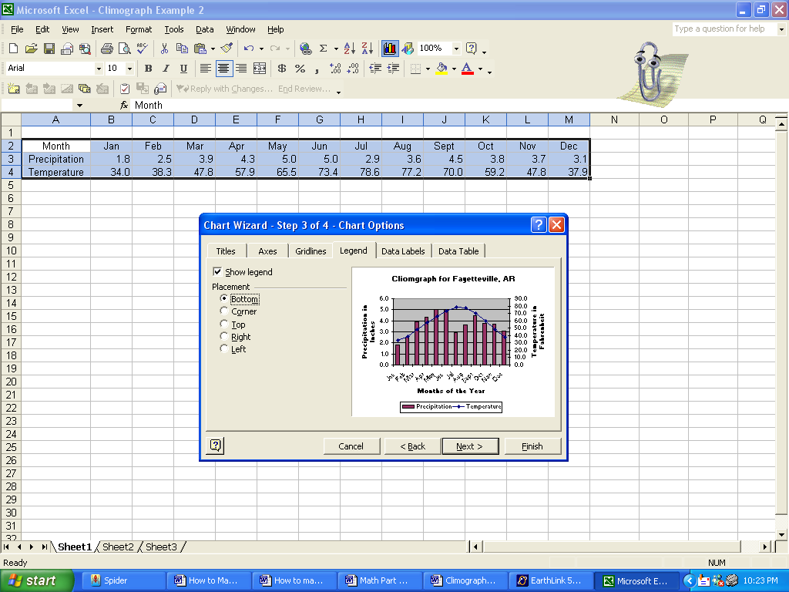

6. Adjust the size of your chart by dragging the black boxes.
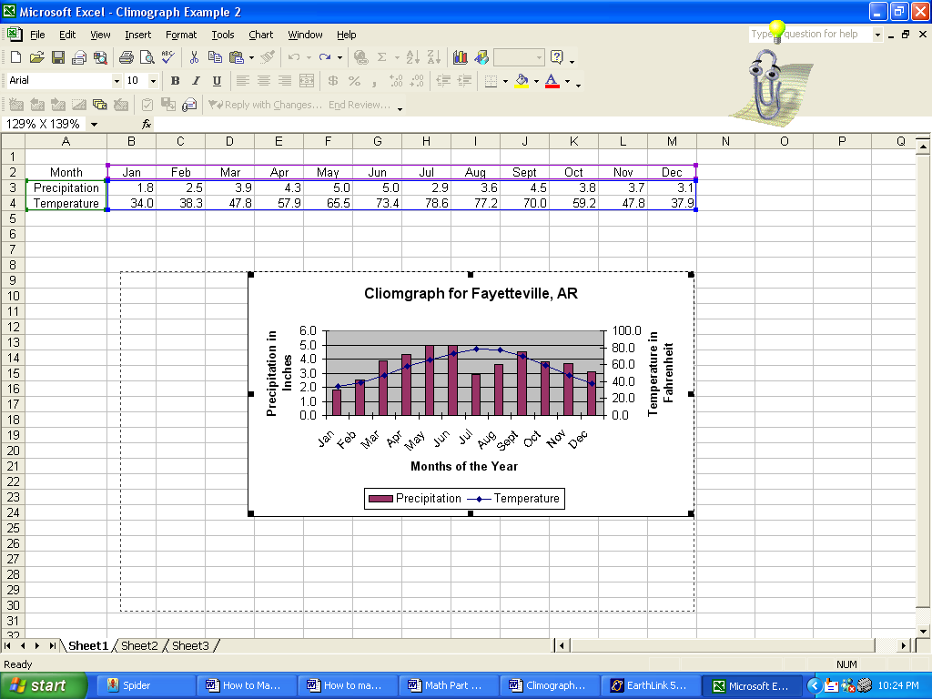

7. If you need to change either scale, right click on the scale and choose “Format Axis”.
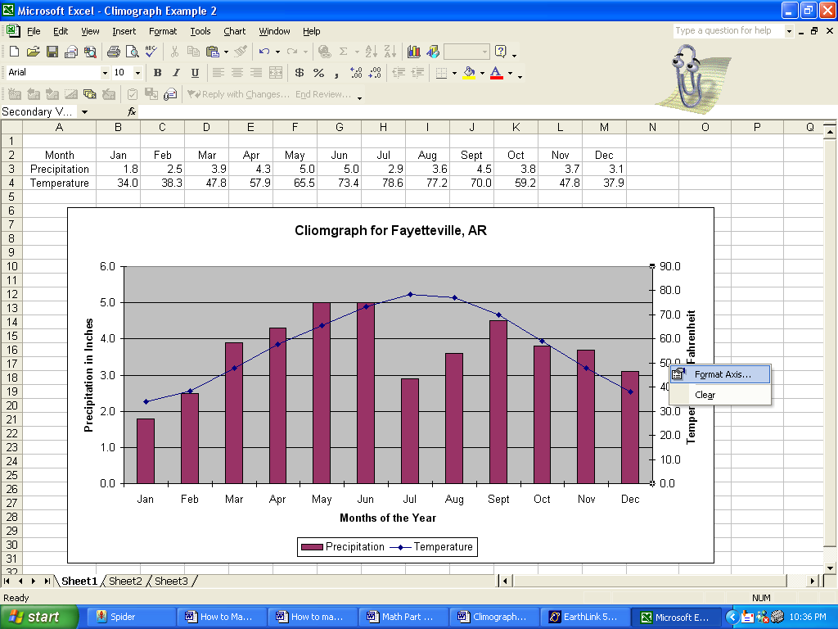

8. Choose the “Scale” tab. Your minimum value should be 0; choose appropriate maximum, major unit, and minor unit for your data. Press okay.
