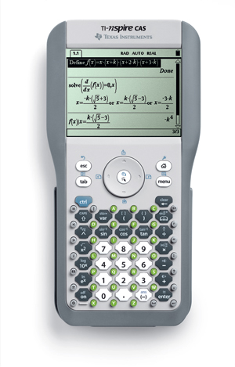
Texas Instruments TI-NspireTM or TI-Nspire™ CAS

Date: Saturday, May 3, 2008
Time: 9:00 am – 3:30pm
Location: Center for Math & Science Education
346 N. West Avenue, #202
Fayetteville, AR 72701
Need Directions? www.uark.edu/~k12info > Directions

Come experience and try the new TI-Nspire™ or TI-Nspire™ CAS handheld at a FREE workshop.
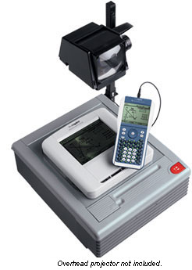
Texas Instruments handhelds can enhance the teaching and learning of middle and high school mathematics and science students. This workshop will give you a chance to learn how to use TI-Nspire™ handheld. The session will provide learning opportunities for participants of all ability levels starting with novice users.

Register by April 19, 2008 and your name will be placed in a drawing for a
NEW TI-SmartView™ 2.0 Emulator Software for TI-84 Plus Family (valued at $135)
To learn more about this software visit:
http://education.ti.com/educationportal/sites/US/productDetail/us_smartview.html


DOOR PRIZES—must be present to win

The TI-Nspire™ handheld has a removable keypad that allows it to be used as a TI-84 graphing calculator. The TI-Nspire™ was designed to match instructional practices that research shows improves both student engagement and learning.
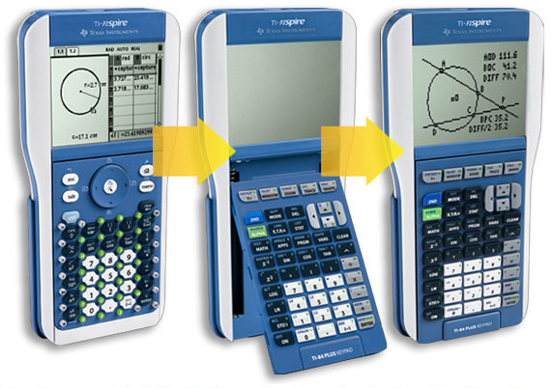

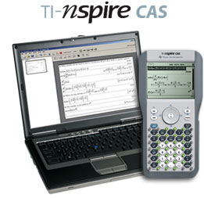

The TI-Nspire CAS handheld and computer software help
educators incorporate CAS (Computer Algebra System)
as a tool for students to explore, evaluate and simplify More product information at education.ti.com
expressions, numeric problems, and variables in symbolic form.

